Which Sectors Are Pulling The UK Economy Out of Recession?
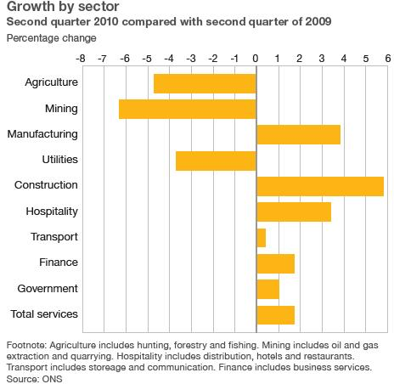
The recovery may be a bit feeble (estimates have growth have recently been revised downwards) but it is now a year old. There’s the VAT increase (which rises to 20% in January), cuts to government spending and low wage growth still causing some alarm (fuelling fears of a ‘double dip’ recession). But where has current growth come from?According to the BBC who quote one expert, “Manufacturing has led the recovery so far. The sectors that fall the furthest tend to come back fastest as well”. Manufacturing tends to decline fast and then recover fast because of the way that other businesses deal with their stock. In a recession, retailers will try to leave it as late as possible to replace the goods they have in stock in case they do not get sold. Similarly, businesses will leave it as late as possible to replace or update equipment.
Now that the recovery seems to be here, businesses have to replace their stock to take advantage of the upturn, which creates business for manufacturers that survive the recession. “The process of restocking has finished and what we’re seeing now is real demand. There has been particularly strong growth from manufacturers exporting to emerging markets in Asia,” says the chief economist at the manufacturers’ organisation, EEF. With the pound relatively weak and some signs of recovery among the countries that are UK’s biggest customers in Europe, manufacturing is bouncing back. The service sector, on the other hand, shrank less significantly in the recession, partly due to continuing demand from the public sector, and has grown less since it ended. Planned government spending cuts are a big worry for the service sector.
Between April and June this year, the biggest growth area - compared with the same period of 2009 - was construction. This was large because the sector had slowed down so much in the recession that any activity would show strong growth.

