What really caused the Euro Zone crisis?
World leaders probably spent more time worrying about the eurozone crisis than anything else in 2011.
And that was in the year that featured the Arab Spring, the Japanese tsunami and the death of Osama Bin Laden. What's more, 2012 looks set to be not much different. But as eurozone governments hammer out new rules to limit their borrowing, are they missing the point of the crisis?
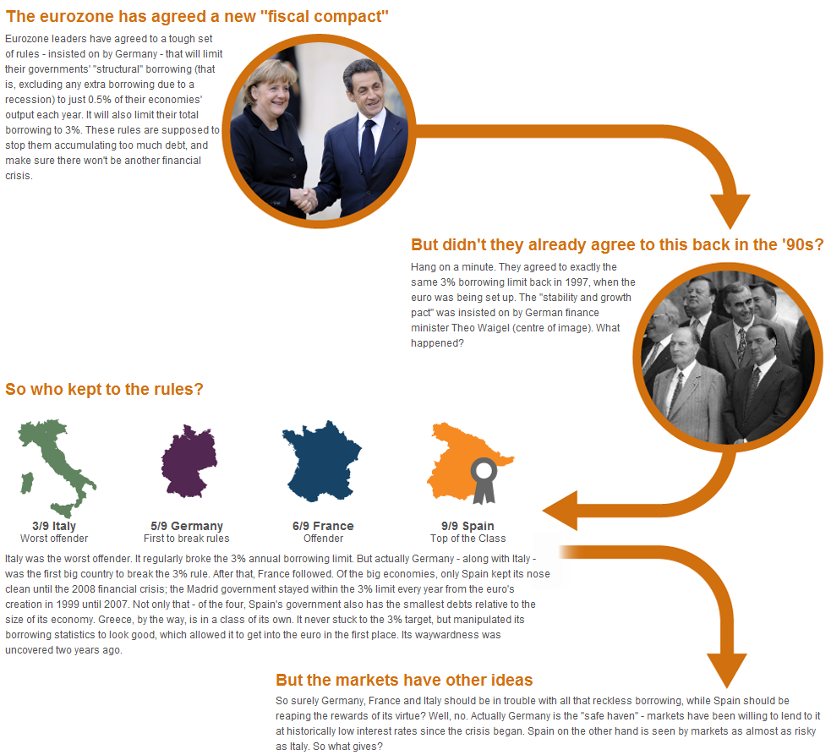

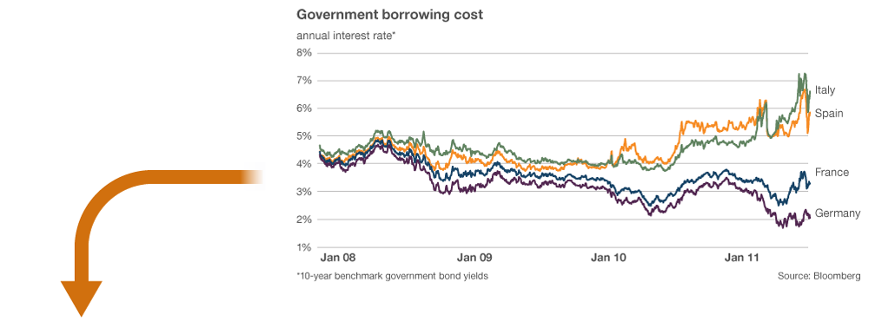
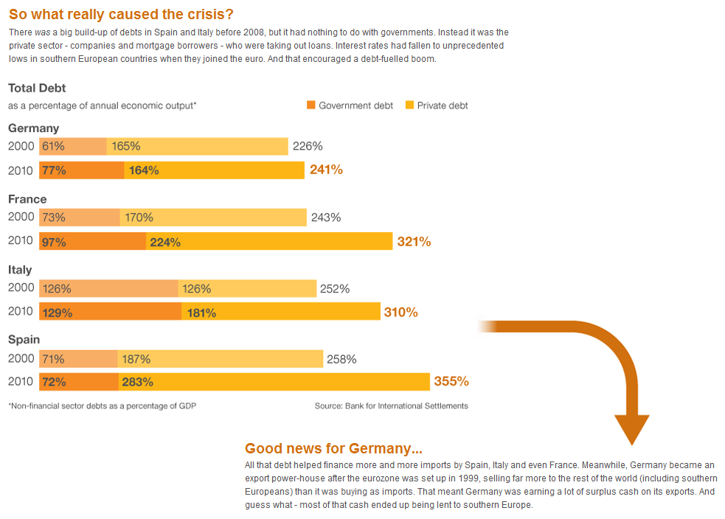
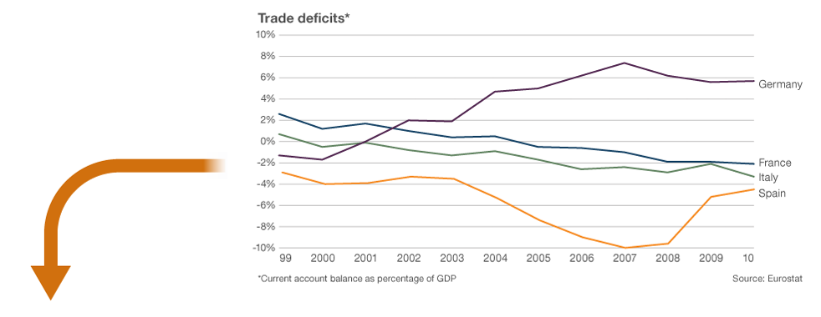
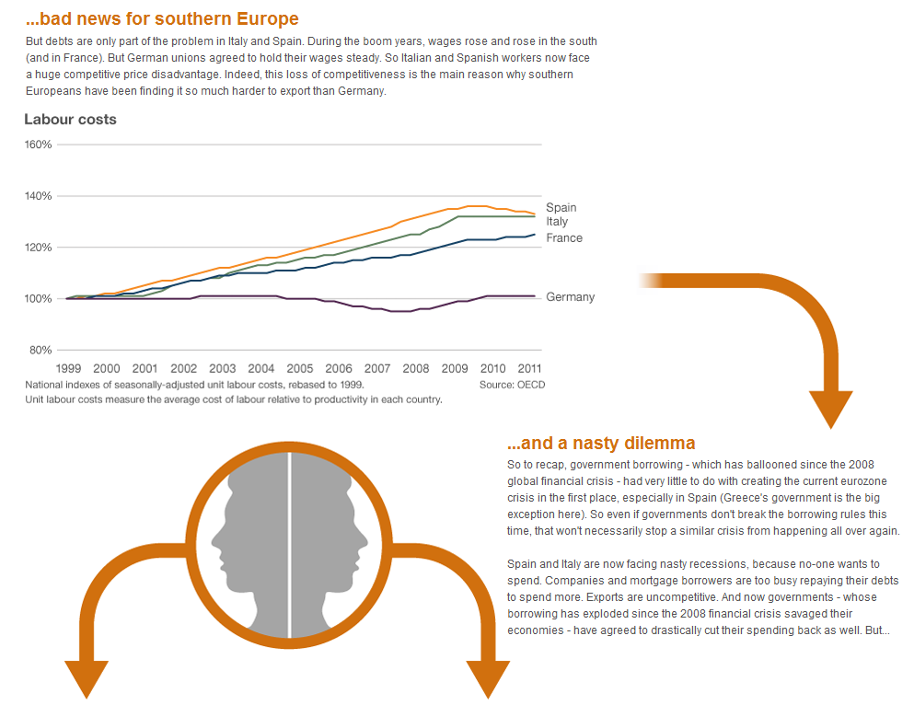
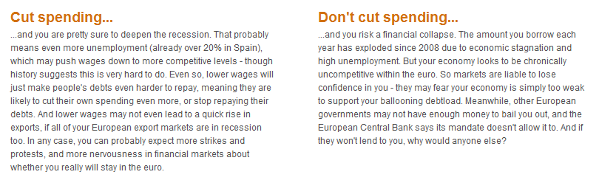

Questions:
- What effect may the euro zone crisis have on UK businesses;
  - Investing in EMU countries
  - With operations in EMU countries
  - Who rely on imports from EMU countries
- What effect may the crisis have on the UK economy?

