Was privatising British Rail a mistake?

More than one train in eight is running late despite the spiralling cost of rail fares, a damning report on the state of Britain’s railways has revealed.
The Office of Rail Regulation (ORR) claimed that nearly 400,000 passengers face delays every day because of track and signal failures.
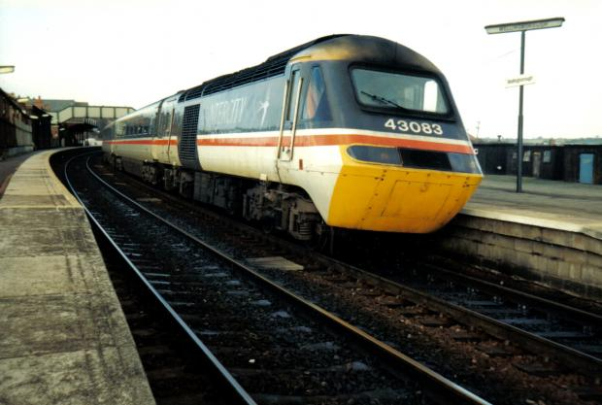
This latest indictment of Britain's trains comes despite the fact that fares have risen by more than 27 per cent since the creation of Network Rail, a private company which oversees infrastructure, in 2002. Ticket prices are expected to go up by as much as 45 per cent over the next eight years.
Given the high cost and poor performance of the railway, do you think it was a mistake to privatise British Rail in 1996? Is the problem not privatisation itself, but the way in which it has been handled?
Is it possible to glean the benefits of privatisation from an industry that, by its nature, must function in part as a monopoly?
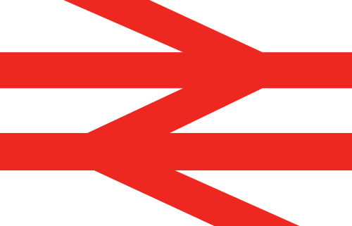
Are we better or worse off now than we were in the days of British Rail?
Why does Britain's rail network perform so much worse than those of other European countries? Or does it?

