Wal-Mart and Price Discrimination in the USA
Wal-Mart is currently the largest retailer in the world. With more than 4,500 stores, Wal-Mart generated $240 billion in sales, which accounted for a little less than 2.5 percent of the U.S. gross domestic product in 2002 (Bureau of Economic Analysis, U.S. Department of Commerce Website, and Fortune, February 18, 2003). Wal-Mart's success, however, is not universally admired. In fact, it is often accused of engaging in anticompetitive business practices.
Many smaller retailers and some consumer advocates allege, for instance, that Wal-Mart intentionally and unfairly quashes competition through extremely low prices. Because of Wal-Mart's size, the argument goes, it can afford to suffer extremely low prices until smaller businesses are forced to close their doors, leaving Wal-Mart as the only retailer in town. Antitrust economists refer to the anti-competitive practice of which Wal-Mart is accused as predatory pricing. 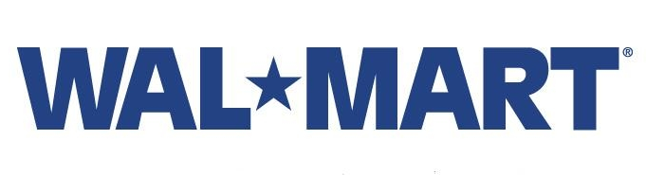
To convict a company of predatory pricing, it must be shown that the company prices its products below its costs. But a highly efficient distribution system and retailing expertise give Wal-Mart a cost advantage that enables it to price its products below the competition and still make a profit. In the view of antitrust law, this is healthy, rather than unfair, competition.
Unable to stop Wal-Mart on the predatory pricing front, competitors have recently put blame on its supply chain. For example, Mexican discounters Controladora and Gigante recently complained to Mexico's Federal Competition Commission (CFC) that Wal-Mart de Mexico pressures wholesalers and manufacturers into better prices (Business Week, September 16, 2002). The argument is that Wal-Mart, because of its size, is able to threaten abandonment to suppliers unless it receives lower prices. When suppliers cave in to Wal-Mart's pressure, Wal-Mart gains an additional competitive advantage because these suppliers are charging relatively higher prices to disadvantaged retailers for the same product.
If U.S. retailers, such as Kmart or Target, were to make the same allegation against Wal-Mart and its U.S. suppliers, how would U.S. antitrust law be applied?
Such allegations claim that retail suppliers are engaging in price discrimination, which is the practice of selling identical products to different buyers (retailers in this case) at different prices, where the price difference is not based on any cost difference. For example, a laundry-detergent manufacturer is price-discriminating if it sells its 64-oz container to Wal-Mart for a unit price of $1.79 but sells it to Kmart for $1.92.
The most relevant piece of antitrust legislation concerning this practice emerged from Depression-era sympathy for the local retailers, so-called mom-and-pop shops, against a new form of retailer: the chain store. The chain store in the early twentieth century bought in such large quantities that it could bargain with suppliers for cheaper prices. Because the traditional shops were not entitled to these bargain prices, chain stores' discounts were generally viewed as unfair.
The Robinson-Patman Act of 1936 was a result of this public outcry against the chain store. In fact, the Robinson-Patman Act is historically referred to as the "antichain-store act." The act prohibits sellers from charging different prices to different buyers for identical products when the effect might be injurious to competition. Thus, the act was intended to eradicate the competitive advantage of the chain store.
Note that a necessary condition for violation of Robinson-Patman is that competition has been injured. Therefore, Robinson-Patman does not make illegal the practice of price discrimination by retailers themselves. For example, consider a grocery store charging $3.99 for a box of cereal to one customer, but charging $3.49 to another customer who had clipped a coupon from a Sunday newspaper. In this case, the grocery store is not violating Robinson-Patman because these two customers do not compete in the resale of cereal.
Since 1936, the economic benefit of the Robinson-Patman Act has been debated. On the one hand, Robinson-Patman is one way to ensure that competitors will be protected from those whose only advantage is size. Thus, Robinson-Patman is seen as preserving competition, the most important force in a market economy.
Many antitrust economists disagree with this reasoning by arguing that the act rewards less-efficient competitors, imposes higher prices and lower sales, and provides less economic benefit overall.

