AS Business Studies
Using Budgets – Variance Analysis Unit 2

Laura and Mary run a medium sized fashion retailers “Trend Boutique” in Fulham, London. The following figures are their budgeted figures, and their actual figures:
 | Budget | Actual | Variance
Sales Revenue | £650,000 | £645,000
Fixed Costs | £46,000 | £44,000
Labour Costs | £230,000 | £256,000
Material Costs | £98,000 | £94,000
Profit | £276,000

Questions:
- Calculate the actual profit and insert it on to the table
- Calculate all of the variances and indicate whether they are favourable or adverse.
- Suggest two possible reasons for:
  - The sales revenue variance
  - The labour cost variance

Variance Analysis Highlights Problems at Highcroft Hotel
For the second moth running, Highcroft Hotels had recorded lower profits than expected. The variance analysis is shown below:
 | January (£000s) |  |  | February (£000s)
 | Budget | Actual | Variance | Budget | Actual | Variance
Sales Revenue | 85 | 80 | 5 A | 105 | 95
Food/Drink Costs | 36 | 34 | 2 F | 42 | 43
Labour Costs | 12 | 15 | 3 A | 13 | 16
Fixed Costs | 16 | 18 | 2 A | 16 | 15
Profit | 21 | 13 | 8 A

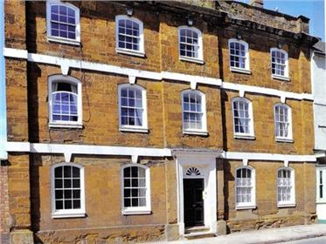
The management of the hotel were particularly concerned about two of these variances. The sales revenue was substantially below budget – yet the number of guests staying at the hotel was almost exactly as they had originally forecast. Also, the adverse food and drink variance in February was a concern. With the guests spending less than budgeted, how had food and drink costs risen above budget?
The managing director of the hotel was relieved that these problems had been spotted early in the year. She was determined to take action which should solve these adverse variances in the months to come.

Questions:
- Calculate the variances for February and state whether they are adverse or favourable.
- Explain the importance to the hotel of using monthly variance analysis – even though budgets are set for the whole year.
………………………………………………………………………………………………………………………………………………………………………………………………………………………………………………………………………………………………………………………………………………………………………………………………………………………………………………………………………………………………………………………………………………………………………………………………………….
- Analyse the possible reasons for the sales revenue adverse variance and the food and drink adverse variance in February.
…………………………………………………………………………………………………………………………………………………………………………………………………………………………………………………………………………………………………………………………………………………………………………………………………………………………………………………………………………………………………………………………………………………………………………………………………………………………………………………………………………………………………………………………………………………………………………………………………………………………………………………………………………………………………………………………………………………………………………
- How might the managing director of the hotel overcome these adverse variances in the coming months of the year?
……………………………………………………………………………………………………………………………………………………………………………………………………………………………………………………………………………………………………………………………………………………………………………………………………………………………………………………………………………………………………………………………………………………………………………………………………………………………………………………………………………………………………………………………………………………………………………………………………………………………………………………………………………………………………………………………………………………………………………………………………………………………………………………………………………………………………………………………………………………………………………………………………………………

