UK Trade
AS Economics Unit 2
Analyse each of the following graphs showing UK trade statistics:
UK Current Account 2008:
 | £m
Export of goods | 251,102
Import of goods | 343,979
Export of services | 170,399
Import of services | 115,920
Balance of trade in goods and services | -38,398
Income Balance | 26,940
Net Transfers | -13,610

Top 10 Export Destinations 2008

Top 10 UK Import Sources 2008

Top 10 UK Exports By Commodity 2008 (£m)

Top 10 UK Imports By Commodity 2008 (£m)

Current Account Balance 2010 – ONS Pink Book
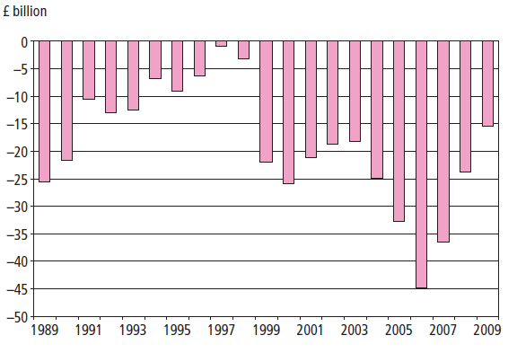

Trade in Goods and Services 2010 – ONS Pink Book 2010
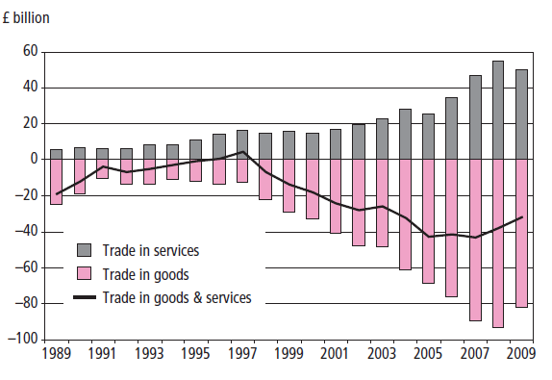

Analysis: The Current Account Balance

Article: Does the current account deficit matter?
At first glance the deterioration in the current account balance looks like cause for concern as the government is continually failing to the one of it’s macroeconomic objectives. In the same way that an individual cannot spend more than she earns unless she runs down her savings or borrows the economy cannot do the same without borrowing from abroad or reducing its savings and investments abroad. However, the fact that the city of London has attracted such high levels of foreign direct investment has meant that there has been sufficient Financial Capital flowing into the UK economy to pay for the deficit. As long as this continues to occur, there is no reason why the UK cannot afford it’s trade deficit. That said, trends in global financial markets can be volatile and it may be unwise to rely on the city of London continuing to be the global financial hub of the world in the long term.
The other indicator to examine is the current account as a percentage of GDP. Until recently this proportion was fairly modest, generally fluctuating between one per cent and 3% of GDP and below that of the late 1980s boom, when the deficit reached as high as 5% of GDP. As long as the country’s generating sufficient income to be able to pay back the accumulated debt, then the account deficit should not pose a problem. Economists believe that not only when the deficit increases beyond about 5% of GDP that the government should have cause for concern. The U.S. current account deficit is around 7% of GDP, for example. Time is also an crucial factor: it is hoped that the UK will not run a large current account deficit indefinitely, but at the moment it appears to be within manageable limits.
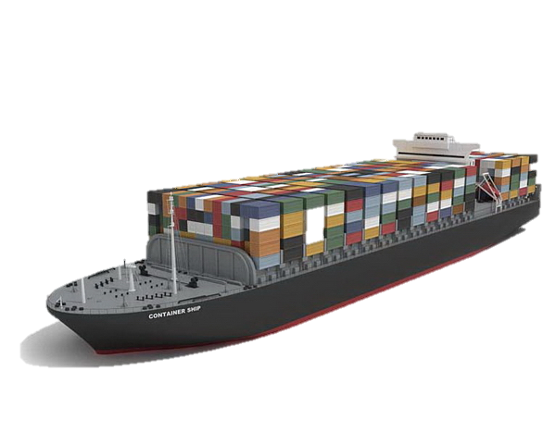
Nonetheless, the record trade in goods deficit does indicate significant structural changes and weaknesses in the UK economy, especially the decline in manufacturing industry in the UK. It reflects the fact the UK goods are often of poor quality and design and poorly marketed, which is largely down to low investment levels and the UK productivity gap. It is also a signs that UK growth in recent years is rather unbalanced, too heavily reliant on consumption, which is sucking in imports and not enough on investment and exports. Whether the collapse in consumer spending in 2008 and 2009 indicates that, in the long awaited rebalancing of UK growth now underway remains to be seen.The trade in goods deficit is a significant problem for the UK given that it is a relatively open economy, with a high percentage of GDP accounted for by imports and exports.

- What does the current account deficit mean for the UK economy? Does it matter?

AS Level Economics
Unit 2
UK Trade Statistics

Mr M Young

Name……………………….

