A2 Business
Interpreting Financial Statements

Thomas Cook Group
The Thomas Cook Group states that it has the overall objective ‘to ensure that it is at all times able to meet its financial commitments as and when they fall due’ (to be able to pay their short term debts with short term assets). An extract from their accounts is shown below.
 | 2007 | 2006
Current Assets | £2,321.4m | £1,433.4m
Of which Stock | £27.4m | £10.5m
Current Liabilities | £3,737.9m | £207,709m

Activities
- Calculate the liquidity ratios for 2006 and 2007.
- Explain what these ratios mean for the Thomas Cook Group.
- Comment on whether you feel Thomas Cook’s financial situation has improved or got worse between 2006 and 2007.
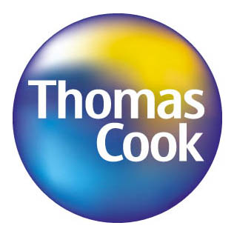
- Do you feel Thomas Cook is able to achieve its objective in;
i)2006
ii) 2007
Justify your argument with reasons.
- Extension: What have Thomas Cook done to improve their liquidity? How might they have done this? What are the benefits of doing this?

