The Prisoner’s Dilemma in the Phone Industry
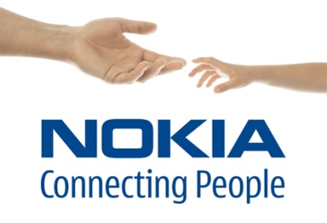
The key to success in this industry (as in any other) is to create a product that people value highly relative to the cost of producing it. The firm that creates the most highly valued product and also develops the least-cost technology for producing it gains a competitive edge. It aims to increase its’ market share and therefore profits. But the R&D that must be undertaken to achieve the product improvements and cost reductions is costly. So the cost of R&D must be deducted from the profit resulting from the increased market share that lower costs achieve. If neither firm (Samsung or Nokia) does R&D, both firms might be better off, but if one firm initiates an R&D activity, the other firm must follow.

The Prisoners’ Dilemma model illustrates (with hypothetical numbers) the dilemma for the R&D game which Samsung and Nokia play. Each firm has two strategies: engage in a £150m a year R&D programme and the costly advertising needed to support it, or spend nothing on R&D. If neither firm spends on R&D they each make a profit of £600m a year (bottom right of pay off matrix). If each firm conducts R&D, market shares are maintained but each firm’s profit is lower by the amount spent on R&D and each firm now makes a £450 profit (top left square).
If Nokia does R&D but Samsung does not, Nokia gains a large part of Samsung’s market. Nokia profits jump to £900m and Samsung’s drop to £300m (top right square). Finally if Samsung conducts R&D and Nokia does not, Samsung gains market share from Nokia, Samsung increases its profit to £900m a year, while Nokia makes only £300m a year (bottom left square).
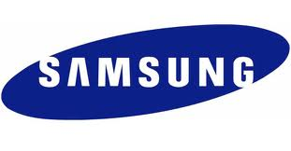

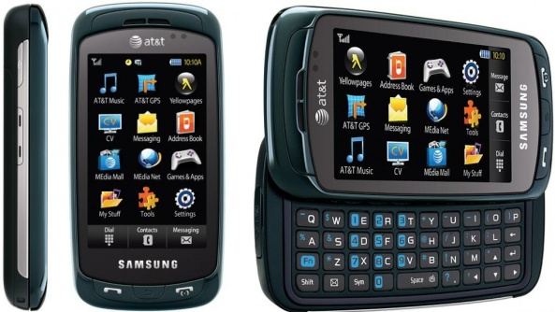
Confronted with the prisoner’s dilemma, the two firms calculate their best strategies. Nokia reasons as follows. If Samsung does not undertake R&D we will make £900m if we do, and £600m if we do not; so it pays us to conduct R&D. If Samsung conducts R&D, we will make £300m if we don’t and £450m if we do. Again R&D pays off. Thus conducting R&D is the best strategy for Nokia, regardless of Samsung’s decision.
Samsung reasons as follows. If Nokia does not undertake R&D we will make £900m if we do, and £600m if we do not; so it pays us to conduct R&D. If Nokia conducts R&D, we will make £300m if we don’t and £450m if we do. Again R&D pays off. Thus conducting R&D is the best strategy for Samsung, regardless of Nokia’s decision.
Because R&D is the best strategy for both players, it is the Pareto Efficient Outcome, but also the Nash Equilibrium. The outcome of this game is that both firms conduct R&D. They make less profit than they would if they collude to achieve the co-operative outcome of no R&D.

This steady on-going R&D activity brings frequent launches of new products which account for the changes in market share in the phone handset industry.

