The Employment Scene
AS Business Studies: Employing People
In October 2012 there were 29.59m people employed in the UK which is 71.3%. There were 2.53m people unemployed, which is a rate of 7.9%. There were 9.04m people who were economically inactive (not seeking or in work) which is around 22.5% and there were 1.57m people claiming job seekers allowance – 4.8%.
Unemployment 1971-2012 (Green Bars Highlight Periods of Recession)
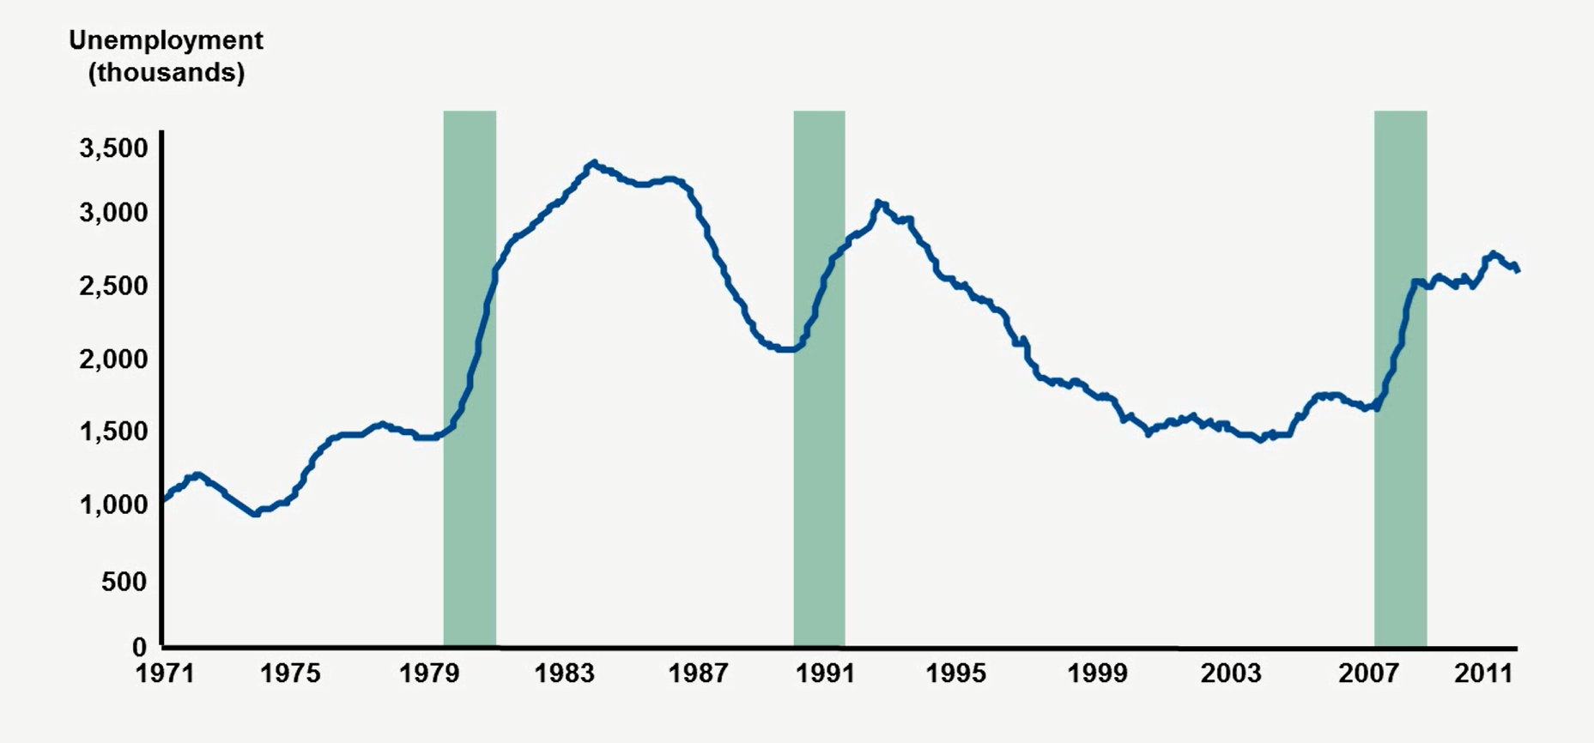
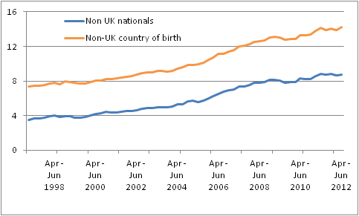
Non-UK National and Non-UK Born People in Employment as a percentage of all people in employment

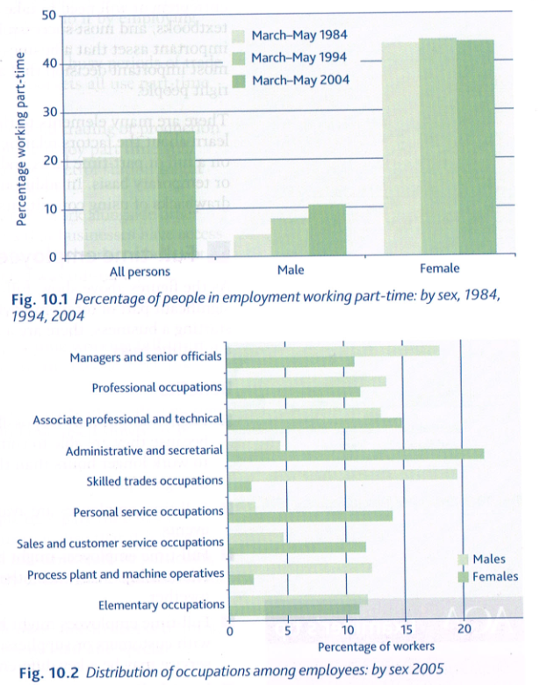

Discussion Points:
- Using the information above, just how important do you feel part time and full time workers are in the UK labour market?
- How has the importance changed over time?

