The Effects of Trade Unions on the Labour Market

You are a team of economists briefed to assemble the latest publication called; Labour Market Trends. In this publication you are to analyse and evaluate trends over the last few years concerning trade unions and speculate about future trends in the UK.

- You are to firstly analyse and discuss the data and information you have been provided with.
- You are to present the data and analysis as clearly and as attractively as possible, as once you have completed your analysis you are to brief the labour minister on your findings. Visual presentations will please the labour minister greatly.
- Once you have finished your analysis, you will present your visual presentations to the labour minister, which will include a prediction of future trends.
- The data you are provided with by your secretary follows on the next few pages.
Holistically you are to produce an executive summary discussing from your findings whether you feel the power of trade unions has declined or got stronger. If so why? What factors have influenced this or may in the future?
Average Union Wage Mark Up for UK Employees
A measure of the success of unions in achieving higher wages for their members is the union mark up. This is the percentage by which the wages of union’s members exceed those of non-union workers doing the same or comparable work.
Union Membership in the Public and Private Sectors of the UK Economy
Trade Union Membership and Density
Trade union density is defined as the percentage of employees who are members of trade unions.
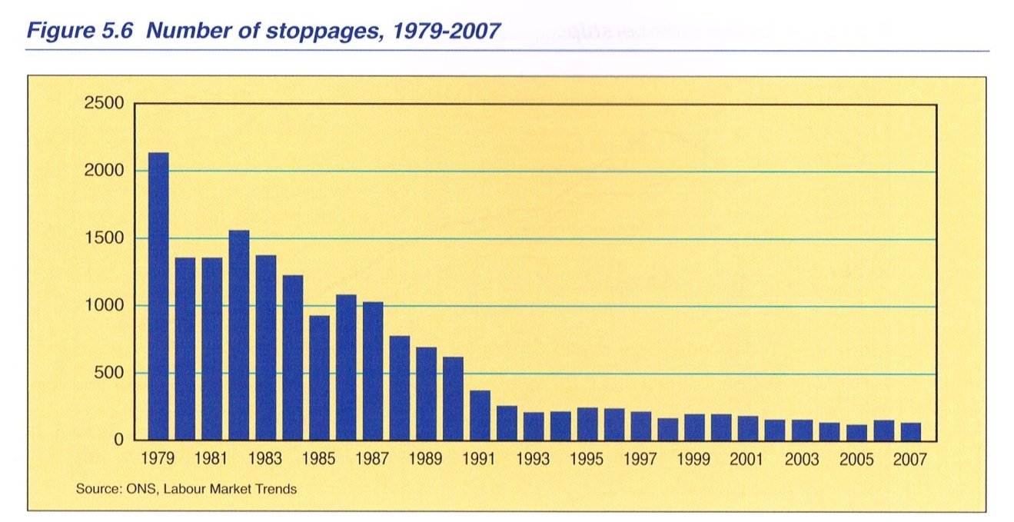
Number of Stoppages 1979-2007

