Supermarkets 'colluded to fix dairy prices'
20 September 2007
Britain's biggest supermarkets were today accused of running a massive cartel over the price of milk, cheese and butter.
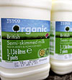
MILK GOES SOUR: Supermarkets have been accused of running a cartel.
The Office of Fair Trading said there was strong evidence that Tesco, Asda, Sainsbury's, Safeway and Morrisons had illegally shared information about planned price increases.
It is believed to be the first time that evidence has been found suggesting the supermarkets have colluded to rip off consumers. If the provisional finding is confirmed, they could face fines running to hundreds of millions of pounds.
The potentially explosive finding comes ahead of a major report from the Competition Commission into whether supermarkets have acted anti-competitively to kill off smaller rivals. The OFT said the cartel had cost consumers about £ 270m through higher prices.
OFT executive director Sean Williams said: 'Consumers have lost out to the tune of hundreds of millions of pounds. This kind of collusion on price is a very serious breach of the law.
'Businesses should understand that where we find evidence of this kind of anti-competitive activity we will use the powers at our disposal to punish the companies involved and to deter other businesses from taking such actions.'
The OFT is not yet publishing full details of the alleged price collusions pending further investigation and responses from the accused companies.
The suspected cartel is also believed to have involved the major milk producers, Arla, Dairy Crest, Lactalis McLelland, the Cheese Company and Wiseman.
The companies are all accused of breaking the 1998 Competition Act by sharing 'highly commercially sensitive information' including the level of price increases in 2002 and 2003.
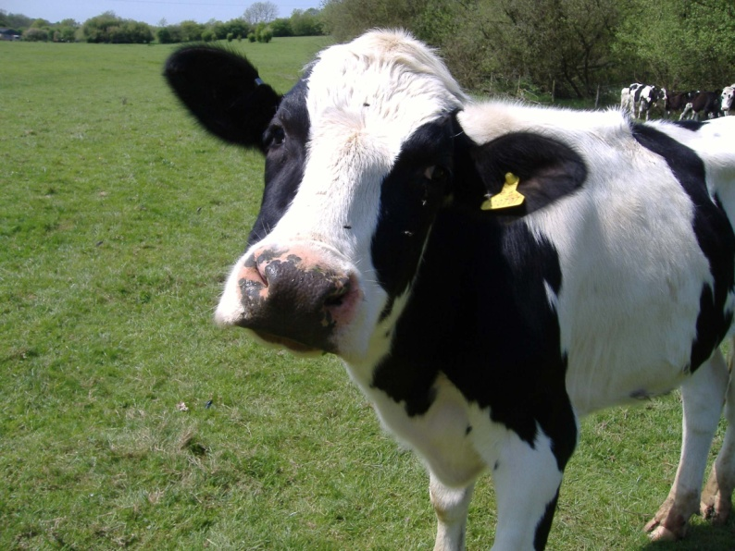
This had the effect of keeping retail prices higher than if there had been true competition. The OFT also said the companies carried on with the practice even after they had been warned by the OFT that they might be breaking the law.
If the OFT concludes that there has been a breach of the Competition Act it could fine the firms up to 10% of their turnover. An OFT spokesman told This is Money: 'It's early days but a fine is likely to be in the hundreds of millions rather than the tens of millions.'
OFT executive director Sean Williams said: 'This is a very serious case. We believe supermarkets have been colluding to put up the price of dairy products. Consumers have lost out to the tune of hundreds of millions of pounds.'
Sainsbury's said today that it would 'vigorously' deny the allegations.
Morrisons chief executive Marc Bolland said: 'We do not believe Morrisons is directly involved.' He said the company was only named in the investigation through its ownership of Safeway, the now defunct supermarket Morrisons took over three years ago.
An Asda spokesman said it was 'disappointed' about the allegations. Tesco said: 'We will vigorously defend any allegations that we have not acted in the best interests of consumers.'
It is the second major price-fixing investigation involving household-name companies by the OFT this year. Last month it fined BA a record £121.5m for colluding with Virgin Atlantic over the level of fuel surcharges on passenger fares.
Kevin Hawkins, director-general of the British Retail Consortium, which represents the supermarkets, told the BBC Radio 4 Today programme: 'Yes, individual supermarkets - not colluding - at the time did put their prices up to consumers on the understanding, with the dairies, that the extra revenue would be passed back through the dairies to the farmers.
'At the time, the farm gate price of milk was low and the supermarkets and the dairies were worried about the possible loss of production and loss of milk supplies. I don't think there was collusion, and certainly not in the way it has been represented.'
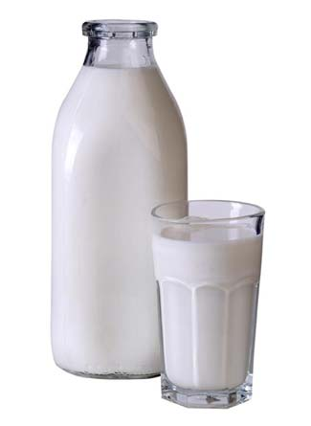
Mr Hawkins said he was working for Safeway at the time of the price hike, and added: "What we were trying to do was to ensure that at least we could get the farm gate price up a bit to help preserve the supply line.'
But Mr Williams, of the OFT, told the programme: 'This is about collusion between supermarkets, it's not about farmers. What the evidence suggests is that farm gate prices didn't actually go up as a result of the collusion.
'So shoppers ended up paying more, but farmers didn't - our evidence suggests - get any more money as a result.'

Read more: http://www.thisismoney.co.uk/news/article.html?in_article_id=424508&in_page_id=2#ixzz16ZkUly4E

