Topic: Marketing Objectives, SMART Objectives.
A2 Business Studies

Task: Identify from the following business marketing objectives, if they are SMART and if so, which parts of the marketing objectives are, Specific, Measurable, Agreed and Time Specific.
You are to take on the role of CEO of each company, and decide whether the marketing department has set SMART objectives, or whether they need changing.

Specific Targets – not vague statements = Highlight in Green.
Measurable Targets – quantitative and achievable = Highlight in Red.
Achievable – agreed by those in the business that objectives are achievable = State whether you feel you agree with the objectives and you think they are appropriate for the type of business, and have been agreed upon by other departments in the business.
Realistic = are the objectives realistic for the business = State whether you feel they are realistic for the specific business you are looking at.
Time Specific = is there a time scale in which objectives are to be completed. Highlight in Blue.

Marketing Objectives of Apple (iPad-Products).
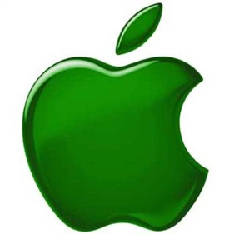
- Increase product awareness among the target audience by 30 percent in one year.
- Inform target audience about features and benefits of our product and its competitive advantage, leading to a 10 percent increase in sales in one year.
- Decrease or remove potential customers' resistance to buying our product, leading to a 20 percent increase in sales which will be made in six months or less.
Do you agree with the objectives and think they are appropriate? Why?
……………………………………………………………………………………………………………………………………………………………………………………………………………………………………………………………………………………………………………………………………………………………………………………………………………………………………………….
Do you feel they are realistic and achievable for Apple? Why?
……………………………………………………………………………………………………………………………………………………………………………………………………………………………………………………………………………………………………………………………………………………………………………………………………………………………………………….
Marketing Objectives of Amazon.co.uk
- We aim to continually build a customer database of at least 40 million households in the UK.
- We aim to achieve a market share of 48%.
- We aim to achieve 75% customer awareness of our brand in our target markets.
Do you agree with the objectives and think they are appropriate? Why?
……………………………………………………………………………………………………………………………………………………………………………………………………………………………………………………………………………………………………………………………………………………………………………………………………………………………………………….
Do you feel they are realistic and achievable for Amazon? Why?
……………………………………………………………………………………………………………………………………………………………………………………………………………………………………………………………………………………………………………………………………………………………………………………………………………………………………………….

Would you change Amazons marketing objectives? What are they lacking?
……………………………………………………………………………………………………………………………………………………………………………………………………………………………………………………………………………………………........................................................................................................................................................

Marketing Objectives of Tesco
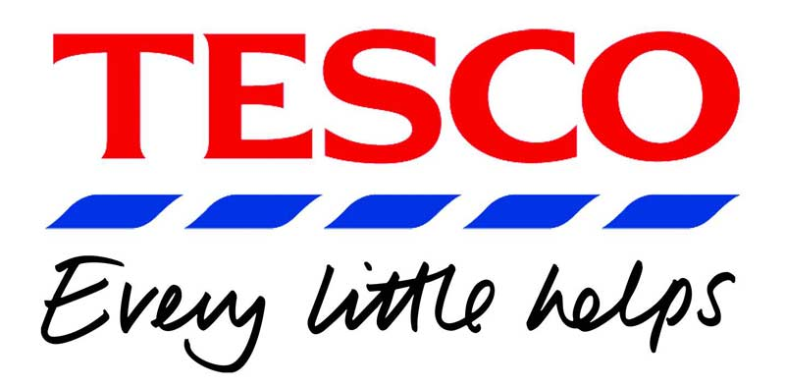
- Aim to develop the brand name in the UK and Eastern Europe by launching a new advertising campaign in both regions of the EU. The campaign will be successful if sales in the UK rise by 1.5% and in Eastern Europe by 8%.
- Aim to increase market share in the UK from 31% to 33% by December 2011 using pricing strategies and increasing the benefits of the Tesco Clubcard for our customers.
- To gain a 10% market share of the internet providers in 32 months time. This projection is based on market research into the opportunities in the market and projections from the finance department.
Do you agree with the objectives and think they are appropriate? Why?
……………………………………………………………………………………………………………………………………………………………………………………………………………………………………………………………………………………………………………………………………………………………………………………………………………………………………………….
Do you feel they are realistic and achievable for Tesco? Why?
……………………………………………………………………………………………………………………………………………………………………………………………………………………………………………………………………………………………………………………………………………………………………………………………………………………………………………….
Would you change Tesco’s marketing objectives? Justify your reasoning.
……………………………………………………………………………………………………………………………………………………………………………………………………………………………………………………………………………………………………………………………………………………………………………………………………………………………………………….

