A2 Business Studies Homework
Topic: Marketing Objectives, SMART objectives

The Virgin Group are currently looking into moving into markets overseas, particularly In Romania, by moving into the railway market. There is a substantial level of growth currently in the country and in the railway market, with estimates of 5% growth per year for the next 5 years. The amount of people using trains in Romania is also on the increase, with a predicted 25% increase in rail travel over the next 5 years. This could in total make the market worth an estimated £128m by 2015. Currently there are around 11 firms operating in the market, none have a dominant market share.
Firm’s Market Share of Romanian Rail Industry 2010.

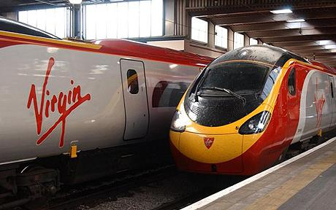
Virgin is planning to use an aggressive strategy to gain a foothold in this market, and then to expand and become the market leader. However the managers need direction and targets set, to enable the Virgin company to move forward towards implementing this strategy.
Your task as Virgin’s Marketing Manager is to ensure that the firm has clear SMART marketing objectives established before the firm enters the Romanian rail markets. The senior management expects five SMART objectives to be established by you for the Virgin Board Meeting on 16th November 2010.

