UK: OFT closes probe into supermarket "price fixing"
By: just-food.com | 18 November 2010

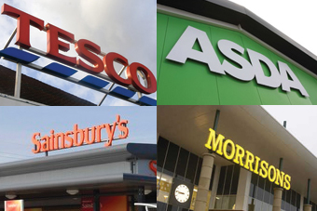
The OFT's investigation had lasted for over two years
The UK's Office of Fair Trading has dropped its investigation into allegations of price fixing between the country's biggest supermarket chains and consumer goods firms.
In April 2008, officials from the OFT visited Tesco, Asda, Sainsbury's and Morrisons and consumer goods giant Procter & Gamble to gather information on the prices of groceries and other goods. The watchdog also requested information from firms including Nestle and Unilever.
The OFT was said to be examining correspondence between supermarkets and 20 other food and non-food companies.
The investigation was studying whether there had been so-called "A-B-C" information exchanges between retailers and suppliers - where supermarkets allegedly give information to manufacturers, which then pass the data on to other grocers to set prices.
In a statement published today (18 November), the OFT, which is set to be merged with the Competition Commission next year, said it had "conducted a thorough review of a significant body of material" but admitted the probe was no longer a priority.
"The OFT considered the future of the investigation in light of its prioritisation principles and concluded that it was appropriate to close the investigation on administrative priorities grounds," the watchdog said.
"The decision to close this investigation should not be taken to imply that the OFT would not prioritise suspected A-B-C information exchanges in the future."

