Office Shoes is a leading high street retailer, popular with the young and fashion conscious. With an established online presence and brand, the company was keen to look at ways to make their website work harder and deliver a better user experience. To reach their aggressive online growth targets, Office shoes needed to address comparatively low ‘on-page’ conversion rates (people who buy products after looking at the website) and increase their average order value. Recognising the need to deliver sales, not just visitors to the website, Office employed a business analyst who identified that success would come from improvements to the website. If improvements weren’t made then any future online marketing campaigns might result in a wasted budget. After working closely with the business analyst, a full analysis of the market was completed. This included:
A2 Business Studies
Topic: Market Analysis, Office Shoes Case Study
- Full website review: identification of strengths and weaknesses in features and functionality.
- Situation analysis: insights into other firm’s shares of the market, new opportunities and key strengths identified.
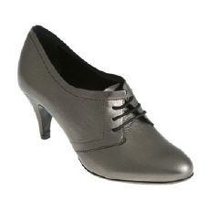
- Competitor benchmarking: an understanding of what is and is not working for competitors, enabling Office to play to their strengths.
- Threats: identification of potential threats to Office’s business plan and future strategies.

