Inflation pushes UK Misery Index to highest since Black Wednesday (Guardian Oct 2011)
Today's inflation data, combined with high unemployment, show the economy is suffering from a mild but nasty dose of stagflation
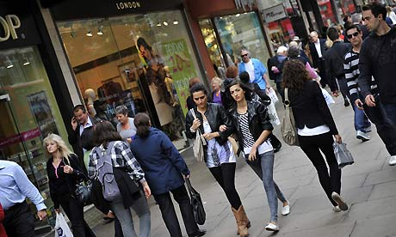

Shoppers in Oxford Street, London. The gap between inflation and wage growth shows real incomes have shrunk. Photograph: Andy Rain/EPA
If you want to know why the British economy is so depressed, you need to look no further than the so-called Misery Index. This is what you get when you add together the unemployment rate and the inflation rate, and after today's announcement of a big rise in the cost of living in September the Misery Index is at its highest level since the immediate aftermath of Black Wednesday in 1992.
Put simply, the economy is suffering from a mild but nasty dose of stagflation, the disease that afflicted Britain at various times from the mid-1970s to the early 1990s. Things are nowhere near as bad as they were in 1975, when an inflation rate in excess of 25% sent the Misery Index above 30, but there has been a marked deterioration over the past 12 months.
The relationship between high inflation and the sluggishness of activity is easy to understand. Prices are up by 5.2% over the past 12 months according to the consumer prices index and by 5.6% using the retail prices index, which is the benchmark for most pay deals. Wages are rising much less rapidly, by 1.8% over the past year excluding bonus payments. The gap between prices and earnings – almost 4 percentage points if the RPI is used as the measure of inflation – shows that real incomes have shrunk over the past year at the fastest rate since the early 1980s.
Consumer spending accounts for roughly two-thirds of the economy's output, so the squeeze on real incomes leads to lower growth and higher unemployment. The weakness of consumer spending has been amplified by the government's fiscal squeeze, which has sucked still more demand out of the domestic economy. It is disingenuous of George Osborne to blame the stagnation of the UK economy on the crisis in the eurozone. The conditions for the slowdown of the past year were in place long before the single currency entered the life-or-death phase of its existence in the summer of 2011.
The high level of the Misery Index heralds a dire winter ahead. Unless consumers sit and shiver without the central heating on, which some of them will, they have no choice but to fork out more for domestic energy. That leaves less to spend on other items, which is why today's inflation figures saw a fall in the cost of clothes and shoes. The special factors that depressed growth in the second quarter of 2011 may unwind in the third quarter, leading to slightly higher growth but the final three months of this year and the first quarter of 2012 will be tough.
The Bank of England and City economists are confident that inflation will come down during the course of 2012, because there will be no repeat of last year's increases in oil prices and VAT. That looks like a fair assumption, but it will take time for the cost of living to fall back below the government's 2% target. It seems unlikely, given the slack in the labour market, that wage growth is going to pick up next year, which suggests that the squeeze on real incomes will continue next year, albeit more mildly.
Economists have been busily scaling down their forecasts for the UK economy. At Capital Economics they now believe there will be no growth at all in 2012, a shockingly poor performance for an economy supposedly on the mend from a deep recession. The fact is, of course, that the economy is not on the mend. It is still desperately sick. The Misery Index will stay high in 2012, because falling inflation will be offset by higher unemployment, which is on course, as things stand, to hit 3 million.

