Measuring the Effectiveness of the Workforce
AS Business Studies Unit 2

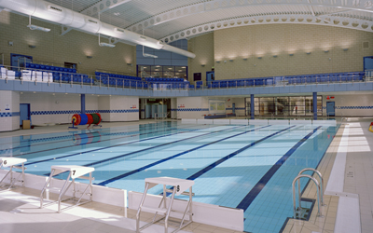
Task 1: Calculating Labour Turnover
Here are the details of a leisure centre which operates in Nottingham. A new training programme and bonus scheme were introduced in year 2.
 | Year 1 | Year 2 | Year 3 | Year 4
Average Number of Employees | 42 | 41 | 42 | 43
Number of Leavers | 3 | 6 | 2 | 2

Questions:
- Showing all of your calculations, calculate labour turnover rate for each year.
- What do figures suggest about the introduction of the new training programme and bonus scheme?
- Make a list of what the costs of labour turnover might be.
Task 2: Calculating Labour Productivity
The leisure centre has provided you with the following details; remember a training programme and bonus scheme were introduced in year 2.
 | Year 1 | Year 2 | Year 3 | Year 4
Average Number of Employees | 42 | 41 | 42 | 43
Number of Leavers | 3 | 6 | 2 | 2
Value of Output (£) | 1,500,000 | 1,300,000 | 1,600,000 | 1,800,000
Total Labour Costs | 948,600 | 951,200 | 948,600 | 962,400

Questions:
- Showing all of your calculations, calculate the labour productivity per year using the output per employee formula.
- Showing all of your calculations, calculate the labour productivity using the labour costs per unit of output method.
- What do these figures suggest about the effectiveness of the workforce?

Task 3: Calculating Absenteeism
Here are even more staff details from the Leisure centre’s HR department.
 | Year 1 | Year 2 | Year 3 | Year 4
Average Number of Employees | 42 | 41 | 42 | 43
Number of Leavers | 3 | 6 | 2 | 2
Value of Output (£) | 1,500,000 | 1,300,000 | 1,600,000 | 1,800,000
Total Labour Costs | 948,600 | 951,200 | 948,600 | 962,400
Average Number of Staff Absent on one day | 5 | 6 | 2 | 1

Questions:
- Calculate the percentage absenteeism rate for years 1-4.
- Describe the trend you observe from the answers in question 1. How might you explain this trend?

