Is China approaching a growth slowdown?
THE global economic and financial crisis made one point abundantly clear: if China wants to continue to achieve high growth in the future, the economy—now the world's second-largest—will have to focus far more on domestic demand than it has in the past and take some of the emphasis off export demand. In other words: in a world that is likely to be devoid of a "consumer of last resort", in the form of the US, for the foreseeable future, China should focus more on its domestic growth forces in the years ahead.
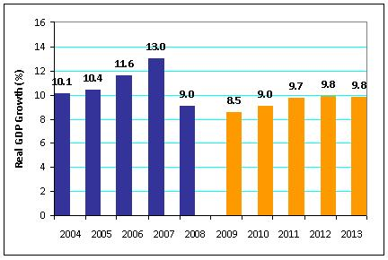
This view is now evidently shared by the Chinese leadership. In October 2010, the Central Committee of the Communist Party of China met in Beijing. The plenary meeting, which lasted several days, was used to develop proposals for the focal points of the 12th five-year plan (2011 to 2015). These proposals subsequently fed through into a condensed version of the five-year plan which was passed in March of this year.

The change of heart, in economic policy terms, within the Chinese leadership is evident if we compare the individual priorities and objectives of the previous, 11th five-year plan (2006 to 2010) with those contained in the current 12th five-year plan: in the past, China has sworn by the mantra of "growth at all costs". This strategy is now giving way to a more development-oriented approach that puts the economic, social and ecological sustainability of economic activity at the forefront. Talk of aiming to double nominal GDP per capita within a ten-year period, which still featured in the 11th five-year plan, has been dropped. Instead, China is looking to achieve stable, but nevertheless relatively rapid economic growth. The new plan makes explicit reference to changes in the country's economic make-up, such as expanding the service sector and modernising industry. The statements made on private consumption are of key significance: its share of GDP is to increase swiftly, household incomes are to grow in tandem with the economy, and wages and salaries in sync with productivity. China is also aiming to lift the incomes of its low-earners and boost the proportion of the population in the middle-income bracket. All of these plans are aimed at achieving an overarching objective, namely to spur domestic demand and, in doing so, reduce the reliance of the Chinese economy on foreign trade.
At the moment, predicting which specific measures the government wants to use to achieve the sort of change in China's growth model that has been outlined in these key objectives is like taking a stab in the dark. What is clear, for one thing, is that change has to, and indeed will, come. For another, it is evident that transforming the Chinese economy is a project that will require a considerable amount of time.
So what does all of this mean for China's medium-term growth prospects? With economic development in the world's industrialised nations leaning to the moderate side, it is presumably illusionary to expect the double-digit growth in GDP that was the order of the day prior to the crisis. Instead, we expect to see average economic growth of around 8.5% a year over the next five years (average 2003 to 2007: 11.7%).
As always, history offers some interesting lessons. Countries like Japan (mid-50s to the mid-70s) and South Korea (in the 70s) enjoyed periods of rampant growth that eventually petered out. Of course, comparisons with other countries are of only limited value, but Japan’s experience in the late 1980s shows that in the long term it is very harmful to the economy to keep growth artificially high (the financial excesses sowed the seeds of Japan’s subsequent difficulties). It is safe to assume that China has digested such lessons and is now determined both to adapt its growth model step by step and to correct the excesses, such as the runaway lending seen in recent years, as swiftly as possible. In the short term this retrofit will cost growth, but the long-term benefit is substantially higher.

