A2 Business Studies Unit 3:
HRM Approaches
‘Soft’ HRM
‘Hard’ HRM

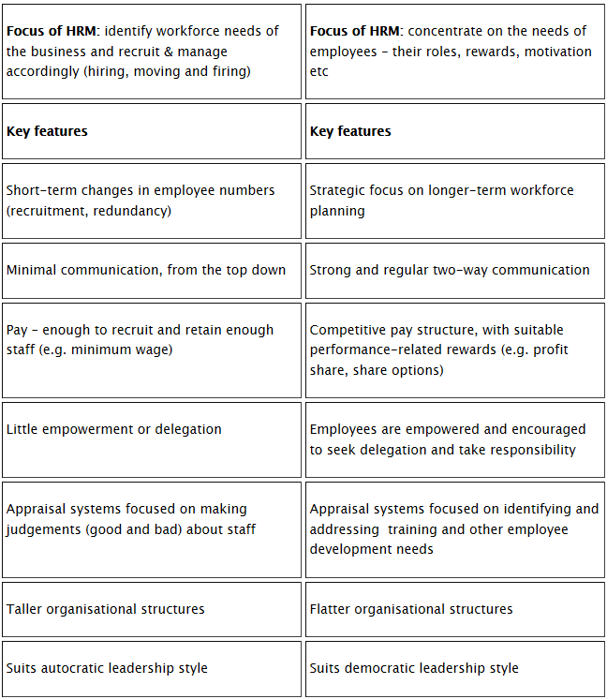
A2 Business Studies Unit 3:
HRM Approaches
‘Soft’ HRM
‘Hard’ HRM

