A2 Business Studies Income Statements and Balance Sheets
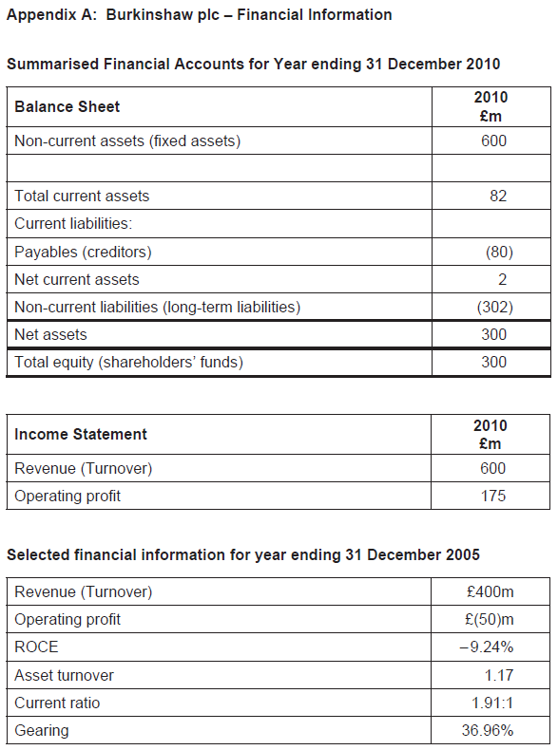
For each of the following income statements, analyse profitability and costs, for each of the balance sheets analyse them from a short term and long term perspective to determine how the business is performing financially. Include any necessary calculations.
