Developing an Effective Workforce at Siemens
AS Business Studies Unit 2
For a business to be competitive, it is important that it has the right number of people with the right skills in the right jobs. Workforce planning enables Siemens to audit its current staff numbers and the skills it has in place as well as identify where it has skills gaps needed to meet its business objectives.
For instance, Siemens is relocating its main plant in Lincoln to a bigger site outside the main city. This will require new skills for the work to be done there. A plan has been constructed to analyse which skills the company has and what training will be needed for staff to use the new technology in the new location.
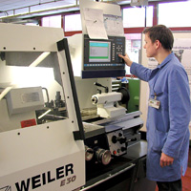
Siemens needs new skills for many reasons:
- to maintain competitive advantage, in ensuring Siemens has people with the right skills to develop new technologies and innovations
- to ensure Siemens has a pipeline of talent and minimal knowledge gaps, for example, due to retirement
- to fill a gap following the promotion of existing employees
Siemens needs to attract employees with the appropriate skills, either by recruiting people into the organisation or by training existing employees to develop more skills.
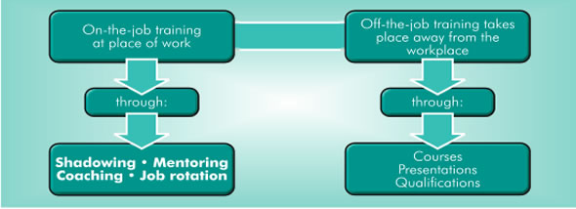
Training involves teaching new skills or extending the skills employees already have.
There are two forms of training.
As well as induction training, where new employees learn the basic information they need to begin working, Siemens has three main development programmes designed for 'Entry Level Talent', i.e. those beginning their career with Siemens after education.

Apprenticeships
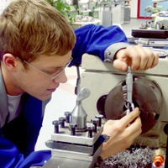
Siemens offers a variety of technical apprenticeships, aimed at school leavers who want to 'earn as they learn'. Apprentices can join a variety of engineering/IT apprenticeships across a variety of locations in the UK, although the majority start their working life from their home town working at their local Siemens site.
Apprenticeship training is a combination of off-thejob college training and on-the-job work experience. Apprentices work to achieve their HND qualifications in their related field.
Siemens believes apprenticeships provide a clear route in developing staff for the future growth of the organisation.

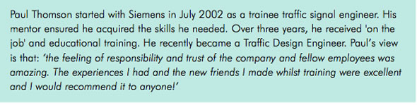Siemens Commercial Academy
The Siemens Commercial Academy was launched in 2005 to further enhance the pipeline of financial and commercial capability within Siemens. The programme lasts four years and is regarded as an alternative to going directly to university.
Aimed at students who have a keen interest in Business and Finance, the programme enables students to rotate around various finance and commercial placements including Accounting, HR, Procurement and Corporate areas.
The trainees who join the programme split their time between studying towards an HND in Business with Finance and working at Siemens.

Siemens Graduate Programmes
Siemens recruits graduates into three core areas of the business:
- Engineering including electrical/electronic, mechanical/mechatronic systems, broadcast, process and manufacturing
- IT covering research, development, design and consultancy
- Business including finance, HR, sales, project and operational management
All Siemens graduate recruits are treated as individuals. They enter the business with relevant skills, knowledge and experience and the potential to do many different roles. Each graduate has a discussion with his or her line manager when they start, to decide on their individual training and development plan.
Where appropriate Siemens supports graduates to gain further qualifications. These include gaining chartered engineer status through institutions such as IET or IMechE. The typical graduate profile is varied.
Questions:
- Define induction training.

- Define ‘on the job training’ and ‘off the job training’

