AS Business Studies Unit 1 Constructing Break Even Charts
Data from ‘Eat Your Fill’ restaurant
Information Needed | ‘Eat Your Fill’ Data
Weekly Fixed Costs | £2,800
Variable Costs per customer (original forecasted figure) | £3
Average revenue earned per customer | £10
Maximum weekly number of customers – the capacity of the restaurant | 600

We can construct a break even chart to show the revenue and costs of a business at different levels of output. Follow each stage carefully by drawing the chart on the graph paper as you go.
Stage 1
Mark out the scales on graph paper. The vertical axis will record weekly costs and revenues in £. The scale will extend from zero at the origin to the maximum revenue that can be earned = 600 customers x £10 each = £6,000. Mark out the scale in squares of £1,000.
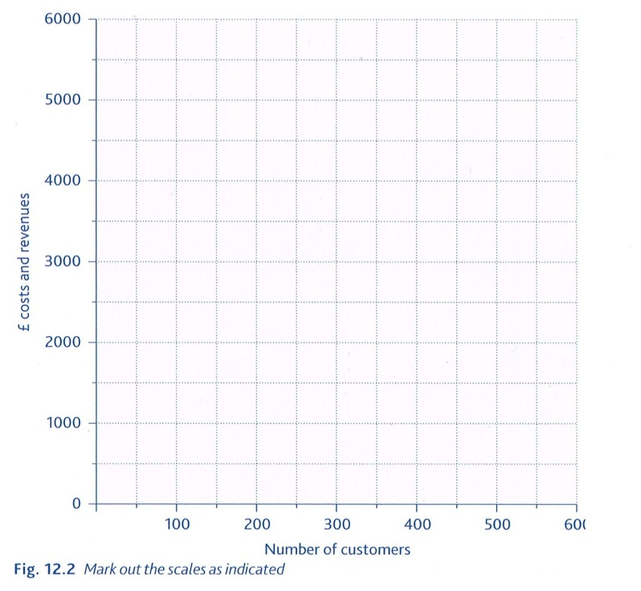
The horizontal axis records the number of customers (or units of output). This scale will extend from zero at the origin to a maximum capacity of 600. Mark out the scale in squares of 100.

Stage 2
Draw in the fixed costs line. Weekly fixed costs are £2,800 and – because they don’t vary with the number of customers – this line can be drawn completely horizontal from the point £2,800 on the vertical scale.

Stage 3
Draw in the variable cost line. Variable costs per customer were forecast to be £3. Start this line at zero – no customers means no variable costs are used in production. Just one more point is needed to complete the variable cost line. At 600 customers a week, total variable costs will be £1,800 – add this coordinate into the graph and then join the two points with a straight line from zero to £1,800.

Stage 4
Add fixed and variable costs together at all levels of output to give the total weekly costs of the businesses. This line STARTS at £2,800 because even with no customers, there will be weekly fixed costs of £2,800. The fixed cost line is then drawn parallel to the variable cost line ending it at 600 customers. To check this – the total costs at 600 customers will be:
£2,800 + (600 x £3) = £4,600. Plot this coordinate. This will give you a total costs line parallel to variable costs.

Stage 5
Add the revenue line to complete the break-even chart. The restaurant’s revenue will be zero with no customers so this line starts at the origin. The other coordinate needed will be at maximum sales revenue:
600 customers x £10 = £6,000. Draw a straight line between zero and £6,000 (at 600 customers).

Stage 6
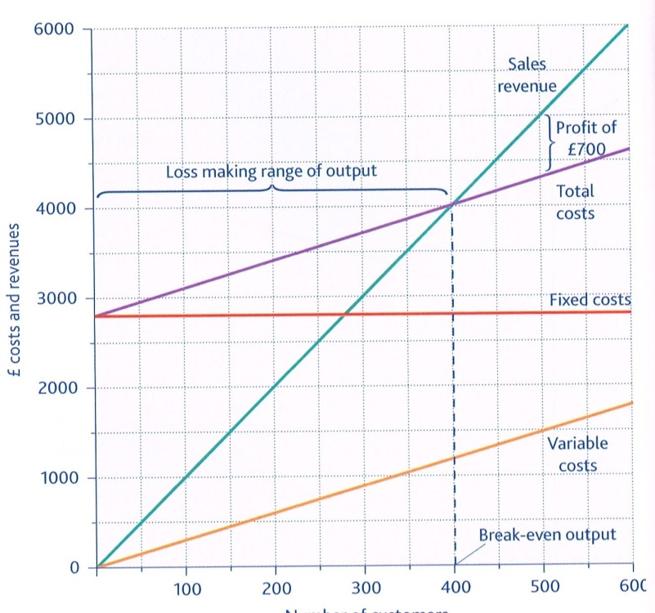
The level of output at which the firm just breaks even can now be shown by drawing a vertical line down to the horizontal axis from where
total cost = total revenue. Any point to the right of this break-even point is profit. This can be calculated by doing Sales Revenue – Total Costs. The amount by which existing levels of output are greater than the break-even point is known as the margin of safety (Current output/customers – Break Even Point). Any point to the left of the break-even point is where the business makes a loss.

Stage 7: reading the break-even chart
From the chart we are able to tell:
- The restaurant’s original forecasted break even number of customers is 400.
- That up to 400 customers a loss is made by the business (loss making range of output).
- After 400 customers a profit is made – for example, at 500 customers the forecasted profit is £700 per week.
- The largest profit is, clearly, made at the maximum level of customers (600). There is a profit making range of 200 customers. 600 (max customers) – 400 (break even customers).

