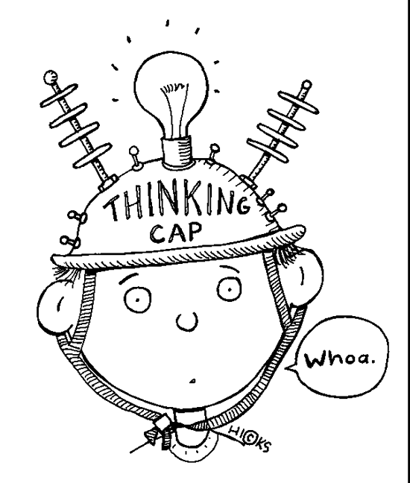
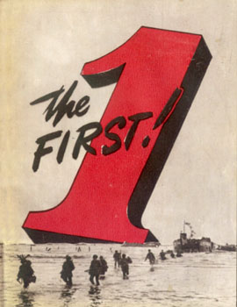
Inflation: Starter Activity
Break the code and use information within it, to answer task 2.
about a
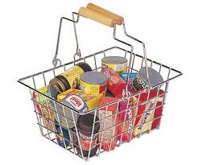
where
you have a . Now, that the
only you can 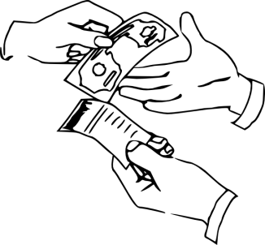 are:
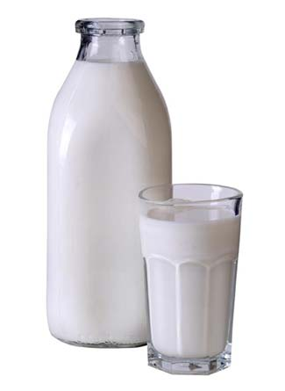, 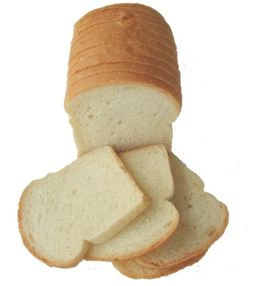 and 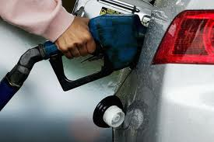 .
They all cost 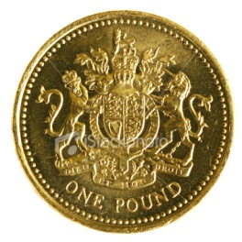.
Task 2: Calculating Inflation
- Write the three items on the previous page into the table for month 1 and then calculate the average price. (Add up all of the prices and then divide by the amount of goods).
Write the total in the box.
- Now assume that in month 2 the average price for each item has changed to:
Bread £1.02, Milk £1.05, Petrol £1.03.
Calculate the average price. (Add up all of the prices and then divide by the amount of goods).
- Now calculate the change in price between the two months. This is known as the inflation rate. (The difference between the average prices of the two months, divided by the average price for month 1, all multiplied by 100.
This gives you a percentage.
This is the inflation rate.
Table:
 | Prices month 1 (£) | Prices month 2 (£)
- Milk
- Bread
- Petrol
Average Price £
Percentage Change %

- Describe what has happened to the prices of goods and consider what may have caused these prices.

