ITEM | FORECAST CASH RECEIVED JANUARY  £ | FORECAST CASH RECEIVED FEBRUARY  £ | APPLICABLE FOR OUR BUSINESS?
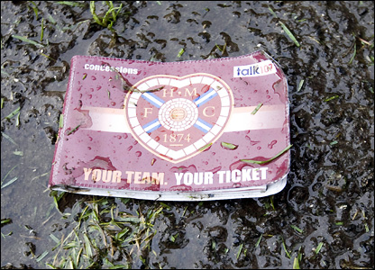  SEASON TICKET SALES | 2000 | 1500
WOMENS WEAR SALES | 3400 | 3600
DVD SALES | 2000 | 1800
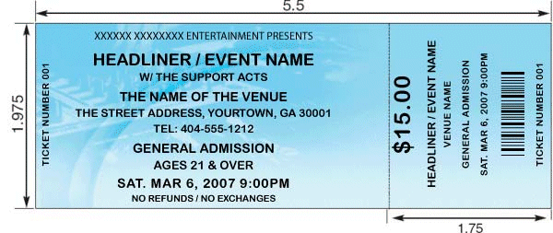  ADVANCE TICKET SALES | 1500 | 1300
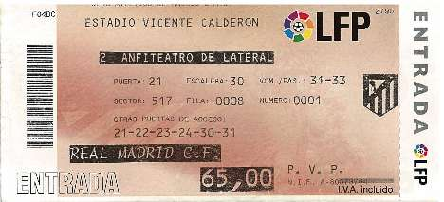  MATCHDAY TICKET SALES | 2400 | 1800
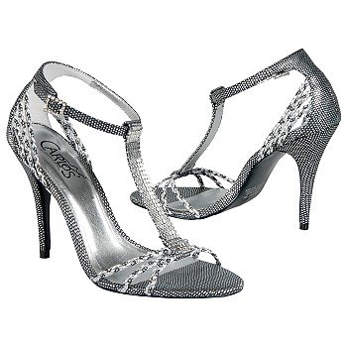  SHOE SALES | 700 | 900
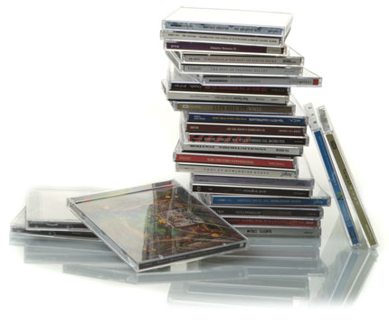  CD SALES | 1100 | 500
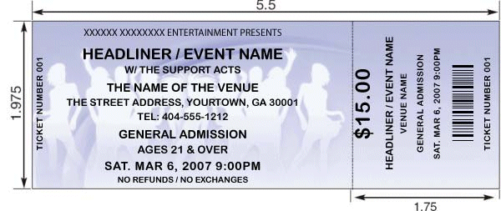  ON THE DOOR TICKET SALES | 1000 | 500
KIT SPONSORSHIP | 3000 | 0
MATCHDAY PROGRAMME SALES | 900 | 1000
MENS WEAR SALES | 1500 | 800
GAME SALES | 1300 | 1200
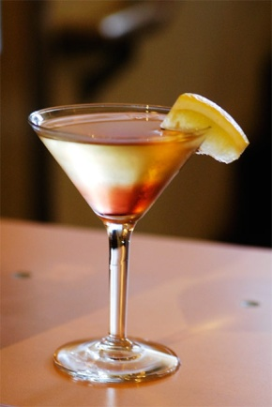  DRINKS SALES | 3500 | 2000
TRADE FAIR SALES | 2000 | 0
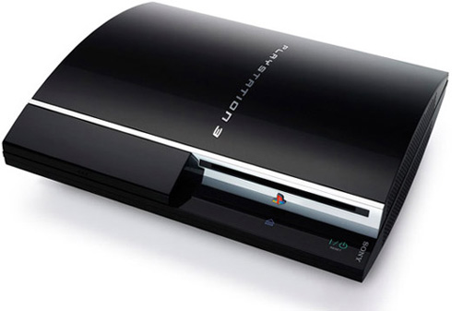  CONSOLE SALES | 1100 | 2200
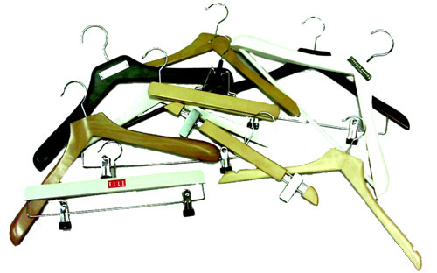  CLOAKROOM SALES | 800 | 300

