ITEM | FORECAST EXPENDITURE  JANUARY  £ | FORECAST EXPENDITURE FEBRUARY  £ | APPLICABLE FOR OUR BUSINESS?
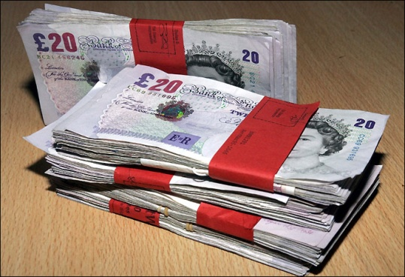  WAGES | 3,000 | 2,500
RENT/PREMISES | 1,200 | 1,200
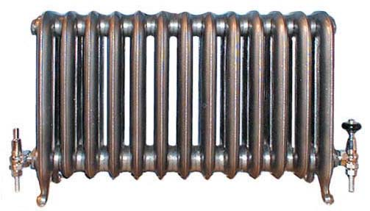  HEATING | 500 | 500
LIGHTING | 600 | 520
ADVERTISING | 1000 | 220

