Canada’s housing market

Look out below

After years of lecturing America about loose lending, Canada now must confront a bubble of its own
Feb 4th 2012 | TORONTO | from the print edition
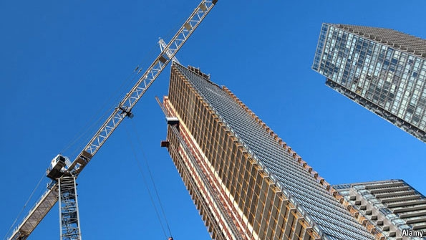
IN FEW corners of the world would a car park squeezed between two arms of an elevated highway be seen as prime real estate. In Toronto, however, a 75-storey condominium is planned for such an awkward site, near the waterfront. The car park next door will become a pair of 70-storey towers too. In total, 173 sky-scrapers are being built in Toronto, the most in North America. New York is second with 96.
When the United States saw a vast housing bubble inflate and burst during the 2000s, many Canadians felt smug about the purported prudence of their financial and property markets. During the crash, Canadian house prices fell by just 8%, compared with more than 30% in America. They hit new record highs by 2010. “Canada was not a part of the problem,” Stephen Harper, the prime minister, boasted in 2010.
Today the consensus is growing on Bay Street, Toronto’s answer to Wall Street, that Mr Harper may have to eat his words. In response to America’s slow economic recovery and uncertainty in Europe, the Bank of Canada has kept interest rates at record lows. Five-year fixed-rate mortgages now charge interest of just 2.99%. In response, Canadians have sought ever-bigger loans for ever-costlier homes. The country’s house prices have doubled since 2002.
Speculators are pouring into the property markets in Toronto and Vancouver. “We have foreign investors who are purchasing two, three, four, five properties,” says Michael Thompson, who heads Toronto’s economic-development committee. Last month a modest Toronto home put on the market for C$380,000 ($381,500) sold for C$570,000, following a bidding war among 31 prospective buyers. According to Demographia, a consultancy, Vancouver’s ratio of home prices to incomes is the highest in the English-speaking world.
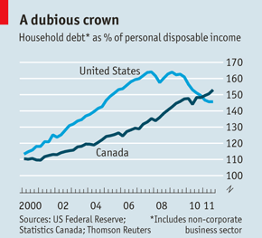
Bankers are becoming alarmed. Mark Carney, the governor of the central bank, has been warning for years that Canadians are consuming beyond their means. The bosses of banks with big mortgage businesses, including CIBC, Royal Bank of Canada and the Bank of Montreal, have all said the housing market is at or near its peak. Canada’s ratio of household debt to disposable income has risen by 40% in the past decade, recently surpassing America’s (see chart). And its ratio of house prices to income is now 30% above its historical average—less than, say, Ireland’s excesses (which reached 70%), but high enough to expect a drop. A recent report from Bank of America said Canada was “showing many of the signs of a classic bubble”.
The consequences of such a bubble bursting are hard to predict. On the one hand, high demand for Canada’s commodity exports could cushion the blow from a housing bust. And since banks have recourse to all of a borrower’s assets, and Canadian lending standards are stricter than America’s were, a decline in house prices would probably not wreck the banks as it did in the United States.
However, the Canadian economy is still dependent on the consumer. Fears about the global economy have slowed business investment, and all levels of government are bent on austerity. The Conservative government’s next budget is expected to put forward a plan to close the federal deficit, now 2% of GDP, by 2015—modest austerity compared to Europe’s, but still a drag on the economy. Few new jobs are being created. Assuming there is no setback in Europe’s debt crunch, slowdown in America or drop in commodity prices, GDP is forecast to grow by a meagre 2% this year. If consumers start feeling less well off, Canada could slip back into recession.
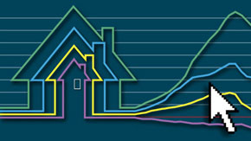
The inevitable landing will probably be soft. Increases in house prices and sales volumes are slowing, and the 2015 Pan American Games in Toronto should prop up builders. “The national housing market is more like a balloon than a bubble,” says a report by the Bank of Montreal. “While bubbles always burst, a balloon often deflates slowly in the absence of a ‘pin’.”
Moreover, the government is trying to cool the market. The banking regulator is increasing its scrutiny of housing in response to concerns about speculators. The Canada Mortgage and Housing Corporation, a government mortgage-insurance agency, says it will have to start reducing its new coverage because of legal limits. And the finance ministry has cut the maximum term of publicly insured mortgages from 35 years to 30. Some bank managers are calling for it to be reduced to 25, the historical norm. Canada’s reputation for financial sobriety is not entirely unwarranted.
However, the state has refused to use its most powerful tool. To protect business investment, the central bank has made clear that it plans to keep interest rates low. As long as money stays cheap, the balloon could get bigger—perhaps big enough to become a fully-fledged bubble after all.

