Burberry and Globalisation

A checkered story

Burberry’s revival reflects the potential of Globalisation, and its limits
Jan 20th 2011 | from the print edition

A long way from the football terraces
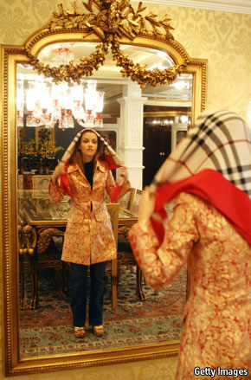
FOR Britons wondering how their country will earn its keep in a world that is tilting eastward, some sectors offer cause for optimism. Newly prosperous foreigners will probably want at least a few things that Britain supplies better than most: higher education, financial services, popular culture. Another, sometimes underestimated strength is fashion: the country boasts influential street stylists and vibrant chain-stores (such as Top Shop), plus some coveted luxury brands, such as Burberry.
On January 18th the 155-year-old label announced a 27% jump in revenue to £480m ($770m) for the last quarter of 2010. Burgeoning sales in Asia (amounting to £150m, up 68% on the same quarter a year earlier) accounted for much of this. Burberry recently bought 50 shops in China that had previously been run by its franchise partners, and would like to open more there. Latin America is another important growth area; new outlets have recently been opened in Brazil and Mexico. Even in Britain, where there are just a handful of stand-alone Burberry shops, the company’s best customers are foreign tourists.
On the face of it, none of this is surprising. Many luxury-goods manufacturers are profiting from the rise of the Asian rich. But Burberry’s story is more interesting than that of many posh brands. For in its own backyard, the firm has had to fight to preserve its reputation for exclusivity.
The problem dates back to the 1980s, when football fans travelling to European cities for matches took a liking to the snazzy clothes sported by the locals. By hook or by crook, they returned home with these garments: Lacoste polo shirts, Sergio Tacchini sweaters, Fila shoes and so on. Thus the “casual” movement was born: a culture of sartorial one-upmanship on football terraces, in a country where working-class men obsessed over clothes long before the rise of the metrosexual. The more patriotic of these casuals began to adopt home-grown brands, and Burberry, previously the preserve of greying executives on golfing holidays, became a favourite.
By the early 2000s the company’s distinctive camel-coloured check had become the uniform of the “chav”, the stereotypical white working-class delinquent looking for trouble. Bouncers and taxi drivers learned to turn away young men sporting Burberry baseball caps and jackets. When Daniella Westbrook, a soap actress, was photographed with the Burberry check adorning herself, her daughter and her pushchair, the brand’s elite reputation seemed to be lost.
Painstakingly, and without much outward snootiness about its new and unexpected clientele, Burberry fought back. The check pattern began to appear less and less on its garments. The company cracked down on vendors selling counterfeit versions of Burberry clothes at discount rates. More daring designs were adopted to court opinion-formers in the fashion world (Burberry had traditionally specialised in trench coats and other well-made basics). Two American women are credited with bringing about many of these changes: Angela Ahrendts, the company’s current CEO, and her predecessor, Rose Marie Bravo.
In Britain the brand has been largely mended. Abroad it was hardly tainted in the first place. Foreigners continued to see Burberry as the august outfit that clothed Ernest Shackleton for his Antarctic expedition nearly a century ago, not the favoured label of a subculture they could barely comprehend. Modern economics and technology allows Chinese, Brazilian and American consumers to buy the wares of a London firm. But it has not made it that much easier to grasp the cultural nuances of another country. Had Burberry’s chav association been known abroad, the damage would have been greater, and the brand might have been harder to turn around. Burberry has benefited from globalisation, and from its limitations too.

Questions:
- How has Burberry benefitted from globalisation?
- What problems has Burberry experienced as far as globalisation is concerned?

