Behind every cloud, another cloud

The past year was a rotten one for Britain’s economy; 2012 will feel worse
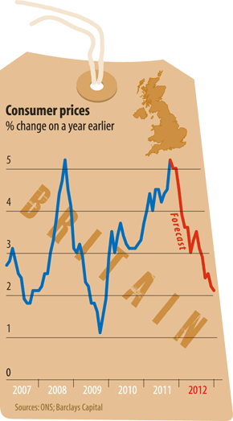
A decade ago, Britain came through the dotcom bust with barely a scratch, thanks to a consumer-credit boom and deficit-financed public spending. Those days of easy credit are long gone: consumers are paying down their debts and government finances are deep in the red. The economy’s best hope lies with export demand, but this is growing scarce. The economic outlook for America, Britain’s biggest single-country export market, looks dark. The euro zone, where half of Britain’s exports go, is at risk of imploding.

In September the IMF cut its forecast for Britain’s GDP growth in 2012 to a sluggish 1.6%. Even that may soon look too optimistic; the Economist Intelligence Unit, a sister company of The Economist, expects 0.7% (see “The world in figures”). It seems far likelier that the economy will disappoint than offer a pleasant surprise. The British policy brass feels vindicated for its wariness about the single European currency but scepticism will be no protection against the fallout from the euro’s troubles. Britain is the one big country outside the currency zone that is heavily exposed to euro trouble through its trade and financial links.
The continuing crisis in Europe will have implications for Britain’s deficit-cutting plans. The logic behind the government’s fiscal austerity is that the bond market’s ire can turn quickly from errant euro-zone countries to others (such as Britain) that have large budget deficits. But as Europe’s woes deepen, the harm done by sticking rigidly to the fiscal plan is likely to prove greater than any damage done by deviating from it.
That is in part because money pulled from the euro zone’s trouble-spots has to go somewhere. Some of it will end up in British government bonds, which will look among the soundest of the rich-country credits (admittedly not a healthy peer group). Meanwhile, a dearth of export orders for British companies will push the government to adopt measures in support of the economy. Deep cuts in the state’s day-to-day running costs, including reductions in welfare benefits, will go ahead as planned. But the Treasury will find itself having to finance new capital projects to make up for a shortfall in aggregate demand.
The economy will be lucky to avoid at least one quarter of contraction during 2012. The unemployment rate will be stuck above 8%, the highest rate since the mid-1990s. But two factors militate against a deep downturn.
First, businesses anxious about the economic outlook and fearful of a renewed tightening of credit conditions tend to trim their stocks, postpone planned investment and stop hiring new employees. But this tendency to conserve cash will be limited in the coming months because many British companies have already been piling up rainy-day money. The excess of corporate income over spending has risen above 4% of GDP. That offers a degree of protection against savage cuts in stocks, investment and jobs.
Easy does it
A second helpful factor is the prospect of lower inflation. It is set to fall steadily from a peak of 5% to around 2% by the end of 2012, as vat and energy-price increases drop out of the annual rate (see chart). That will bring some relief to hard-pressed consumers, who suffered a large fall in real income during 2011. Lower inflation will also make it easier for the Bank of England to justify a more aggressive dose of “quantitative easing” (QE)—boosting the money supply by buying government bonds. Because investors will be increasingly reluctant to finance commercial banks, amid worries about their exposure to the euro zone’s sovereign-debt problems, the Bank of England will find itself compelled (with Treasury backing) to buy long-term bonds issued by banks as part of its QE programme.
The pound is set to fall further against the dollar
London will look a cheap holiday destination for Americans next summer but a lot of Europeans are likely to stay at home. The pound is set to fall further against the dollar in the early months of 2012, in part because of Britain’s exposure to the euro zone but also because the dollar rises against other currencies when the world is in trouble. At the low point for the global economy in March 2009, the pound fell to $1.38. It could easily fall as far again in 2012 given how fearful investors are likely to become.
Only the euro looks more vulnerable to a fall. But it will not be much comfort for Britons that some other European economies will be in even worse shape than their own.

