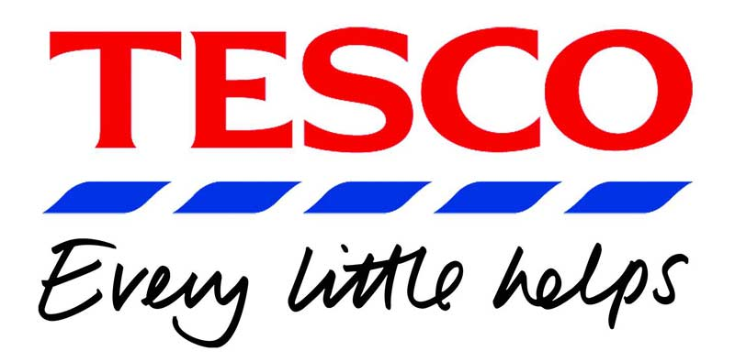
AS Business Studies Unit 2
Measuring and Increasing Profit

Tesco & Sainsbury’s – which supermarket is more profitable?
Bitter rivals for many decades, these two giant retailers have both made big profits in recent years. However, Tesco has grown much more rapidly and now has total sales twice that of Sainsbury’s. By looking at the published accounts of both companies the following sales revenue figures can be compared:
Sales Revenue  (all figs in £m) | 2006 | 2007
Tesco | 39,454 | 42,641
Sainsbury’s | 16,987 | 17,151

Sales are important, of course, but which of these two rivals is more profitable? We will now compare net profit:
Net Profit  (all figs in £m) | 2006 | 2007
Tesco | 2,280 | 2,648
Sainsbury’s | 229 | 520

Sainsbury’s has made lower profits in each of the years being considered. But, is this just because it’s sales are lower? Or could it be that the business is less profitable than Tesco because it also has lower net profit margins?
Questions:
- Explain the term net profit margin
- Calculate the NPM for both companies for 2006 & 2007.
- Give two possible actions Sainsbury’s managers could take to improve profitability. What limitations may exist for the methods you have suggested?

