AS Business Studies
Measuring and Increasing Profit
Case Study 1
Question 1)
A T-shirt retailer, T-Design, sells 50,000 units in 1 year at £5 each. Each T-shirt is purchased by the shop for £2.00 each. Annual fixed costs are £80,000.
Calculate:
- Gross Profit

- Net Profit

Question 2)
The following year the shop again sells 50,000 units for £5 each but gross profit increases to £160,000 and net profit to £90,000.
Calculate the new:
- Gross Profit Margin

- Net Profit Margin

Question 3)
Suggest two reasons for the improvement in the net profit margin.

Case Study 2
Question 1)
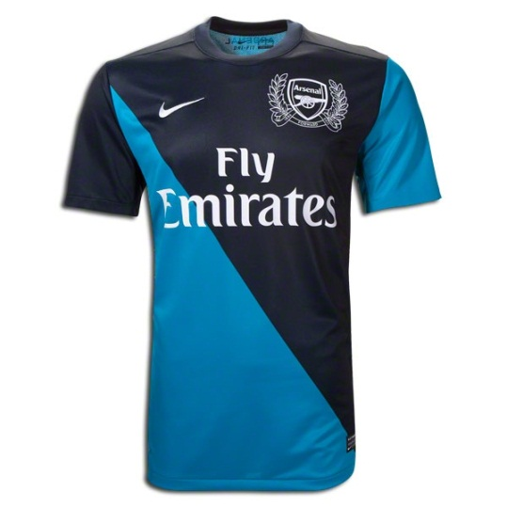
Winston is an entrepreneur looking to start up a sports shop. Winston plans to invest £12,000 in the new business. He has budgeted net profit of £3,000 for the first year of operation.
Calculate:
- The expected return on capital.

- What does this mean?

- Why should Winston be worried if another similar business is making a return on capital of 20% each year?

Extension Question:
In year 2 Winston plans to invest a further £11,400 in the sports shop. He has budgeted profit of £3,800 for the second year of operation.
Calculate:
- Return on capital employed for year 2

- How does this ROCE figure compare to year 1?

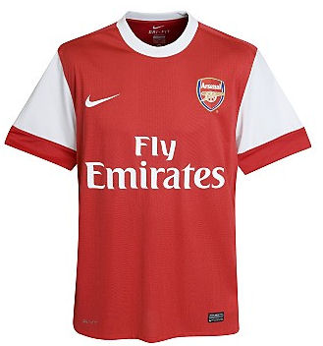
- What factors may have contributed to the change in the ROCE figure?

