Business Cycle Worksheet
Task 1: Labelling the Business Cycle
You must label each section of the business cycle on the following graph:

Task 2: Decide which stage is being described by the bullet points, and fill in the title box.

- Economic growth is high, usually above 2%
- Demand for products is high
- Employment and wages are rising
- Sales and profits of business are high
- UK demand for imports is rising and high
- Interest rates are increasing
- Investment is high

- This stage often needs a stimulus, such as an increase in government spending, or a cut in the rate of tax, or a reduction of the interest rate.
- Economic growth gradually begins to increase.
- Unemployment gradually starts to fall.
- The government wants consumers to be confident in the economy and spend.

- Consumer confidence is falling.
- Firm confidence is falling.
- Economic growth is slowing down.
- Output is still rising.
- However, output growth is falling.
- Increasing number of insolvencies

- Economic growth has been negative for two consecutive quarters.
(6 Months).
- People start to save rather than spend.
- Investment falls.
- Unemployment rises.
- Government spending rises in an attempt to stimulate the economy.
- Prices fall, as demand falls.
- Interest rates fall in an attempt to stimulate spending.

Task 3: Read the BMW, Vauxhall and Banking Case Studies, and prepare to present on the effects of the business cycle on businesses.
You may wish to talk about:
- Employment
- Costs
- Pricing
- Demand for products
- Training of staff
- Investment
- Insolvencies
- Why do different businesses respond differently in a recession?
- How are companies battling against the business cycle and recession? What are the effects of these strategies?

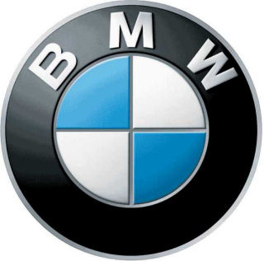
Businesses Response to Business Cycle Case Studies
BMW battles against economic forces
BMW, the world's biggest maker of premium cars, is on course to meet its target of selling 1.8 million cars in 2012. Sales of all three brands owned by the German car maker, BMW, Mini and Rolls-Royce, are expected to continue growing despite dark clouds on thi economic horizon. The company is concerned about three main problems:
- the large fall in the US $ exchange rate - this makes exports from German factories more expensive in the USA

- higher materials and components prices driven by more expensive oil and steel costs
- weakness of consumer spending in the USA as a result of the 2008 slowdown in GDP growth.
How is the company, which made a profit before tax of £3.0bn in 2007, battling against these economic forces?
- Firstly, it is cutting back its German-based workforce and increasing production by 60 per cent at its US factory.

- It is buying many more materials and components from US-based suppliers.
- It is expanding sales in non-US markets such as China and the UK.

- It is cutting prices paid to suppliers.
Mr Reithofer, BMW Chief Executive, is worried about the US slowdown but thinks that mass market car manufacturers will be affected most. ‘A recession takes some time to hit premium car makers. Will it affect us? It depends on how deep the crisis will be’ he said, rather ominously.
Vauxhall offers sabbaticals
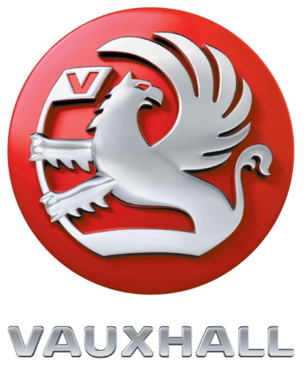
Car manufacturer Vauxhall has offered its workforce at one factory the chance to take a sabbatical on 30 per cent pay. General Motors approached unions at the plant in Ellesmere Port, Cheshire, with the plan last Thursday. Under the scheme, staff would stay away from work for up to nine months between January and September 2009 on less than a third of their basic salaries. A spokesman said the company wanted to avoid making any compulsory redundancies. He said it was 'working with unions to cut structural costs and get us through 2009 without losing staff. He added: 'We want to avoid any forced redundancies.'
If successful, the sabbatical plan could be rolled out at Saab, Opel in Europe and other Vauxhall plants in the UK. But the company said it did not expect there to be a 'huge take-up' on the sabbatical offer. Vauxhall employs more than 5,000 people in Luton and Ellesmere Port. In October, the Ellesmere Port plant stopped production for 14 days because of falling sales in Europe.
Two Banks cut jobs permanently
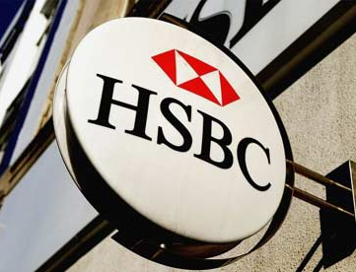
Many IT jobs are under threat in the financial services sector as two leading banks, HSBC and Credit Suisse, announced plans to slash their workforce. The recession has started to impact the workface as more than 1,150 job cuts were announced yesterday across the UK financial sector. HSBC will cut another 500 jobs following a review of the business and 'current economic conditions'. 'We deeply regret taking this step, but we consider it essential to ensure our business is operating as efficiently as possible and that we are best placed to deal with the economic downturn and maintain our levels of customer service,' HSBC, UK managing director, Paul Thurston said. Swiss banking firm Credit Suisse said it is cutting around 650 UK jobs, representing about 10 per cent of the company's UK workforce. A spokesperson for the Swiss bank blamed 'market conditions and projected staffing levels required to meet client needs'.

