Armies of the unemployed
Nov 30th 2011, 17:48 by R.A. | WASHINGTON
LABOUR markets in the euro zone suffered about as badly during the Great Contraction as did the labour market in America. Both economies saw a surge in the unemployment rate that topped out above 10%, and both economies then experienced a slow but steady decline in the rate of joblessness. But where unemployment in America seems to have temporarily leveled off at around 9%, the rate of joblessness in the euro zone is once again rising. As of October, the unemployment rate in the single-currency area was back to 10.3%.
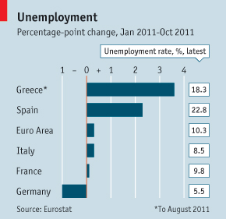
There are several striking facts about recent movements in euro-zone labour markets. The first is the remarkable extent to which increased joblessness is due to deteriorating conditions around the periphery. Since the beginning of the year, Greek unemployment is up nearly 4 percentage points. The jobless rate in Germany, by contrast, has fallen a full percentage point over that period (see chart).
Much of the decline in German unemployment occurred early in the year, when the economy's export machine was running hot. It is interesting to see the extent to which this trend has continued, however. In September, new industrial orders in Germany fell 4.4%, yet from September to October Germany's unemployment rate dropped, from 5.7% to 5.5%. It's no wonder that there is less of a sense of urgency to the crisis in Germany.
It's unlikely that Germany will remain insulated, however. Jobless rates are ticking upward in neighbouring economies Austria and the Netherlands. And a sharp 2012 downturn in the euro-zone economy is increasingly likely.
For the periphery, it is frightening to think that conditions may actually grow worse. Jobless rates in Greece and Spain are already at eye-watering levels. Among young people, those under 25, rates of joblessness across the whole of southern Europe are startling. In Greece, 45% of young people were unemployed as of August, which is the last month for which data are available. In Spain, the rate is 49%, up sharply from a year ago. In Italy, youth unemployment is 29%; in Portugal, it is 30%. Even in France, 24% of young people are without employment.
Within a few months, southern Europe may be home to more young people without jobs than with them. The scale of economic waste embodied in that statistic is dreadful to consider. Moreover, sustained joblessness at these levels is sure to be politically destabilising. Looking over the numbers, it is remarkable to me how quiescent youth populations have been to date. I would not expect that to continue. With economic conditions darkening and public benefits rapidly shrinking, next year's social disruptions are likely to make 2011's look like child's play. That, in turn, may make the effort to hold the euro zone together far more difficult.

