A2 Business Studies: Marketing Strategies
Ansoff’s Matrix

Ansoff suggested that his matrix presents the product and market choices available to a business. The model divides strategies into four quadrants allowing managers to discuss strategies for achieving corporate objectives through the marketing function.

Task: Decide upon which strategy is most appropriate for each businesses’ strategy and place them on the diagram, then justify why you have placed each firm where you have.

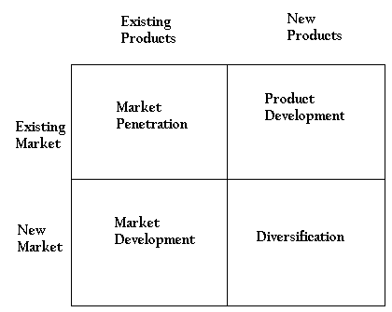

Market penetration
Market penetration is the name given to a growth strategy where the business focuses on selling existing products into existing markets.
Market penetration seeks to achieve four main objectives:
• Maintain or increase the market share of current products – this can be achieved by a combination of competitive pricing strategies, advertising, sales promotion and perhaps more resources dedicated to personal selling
• Secure dominance of growth markets
• Restructure a mature market by driving out competitors; this would require a much more aggressive promotional campaign, supported by a pricing strategy designed to make the market unattractive for competitors
• Increase usage by existing customers – for example by introducing loyalty schemes
A market penetration marketing strategy is very much about “business as usual”. The business is focusing on markets and products it knows well. It is likely to have good information on competitors and on customer needs. It is unlikely, therefore, that this strategy will require much investment in new market research.
Examples of Firms Using Market Penetration Strategies Include:

Justification:

Market development
Market development is the name given to a growth strategy where the business seeks to sell its existing products into new markets.
There are many possible ways of approaching this strategy, including:
• New geographical markets; for example exporting the product to a new country
• New product dimensions or packaging: for example
• New distribution channels
• Different pricing policies to attract different customers or create new market segments

Examples of Firms Using Market Development Strategies Include:

Justification:

Product development
Product development is the name given to a growth strategy where a business aims to introduce new products into existing markets. This strategy may require the development of new competencies and requires the business to develop modified products which can appeal to existing markets. The strategy may include:
- Developing unrelated products or services which market research has identified as being part of the buying decisions of customers.
- Introducing new models of existing products with significant modifications, new functions or services.

Examples of Firms Using Product Development Strategies Include:

Justification:

Diversification
Diversification is the name given to the growth strategy where a business markets new products in new markets.
This is an inherently more risk strategy because the business is moving into markets in which it has little or no experience.
For a business to adopt a diversification strategy, therefore, it must have a clear idea about what it expects to gain from the strategy and an honest assessment of the risks.
- Related diversification: a form of forward, backward or horizontal integration – the firm becomes involved in the activities of its customers, suppliers or customers
- Unrelated diversification: the highest risk strategy – because the business has no experience or detailed knowledge of the key success factors in the market, although there is evidence that it can lead to the fastest growth.
Examples of Firms Using Diversification Strategies Include:

Justification:

