A2 Business Studies Unit 4
Globalisation
'Globalisation' refers to the trend where individual countries become less influential in relation to crossnational bodies. People worry we are turning into one global 'village'. Decision makers are far away. There is fear because such decisions do not take note of what local people need or want. However, as the case study will show, meeting local needs is key to the performance of a business like Siemens'.

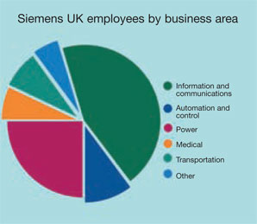
Siemens is multi-national. It operates across 190 separate nation states. Executives in Germany and across the world must make decisions in the best interests of Siemens' shareholders. Most multinationals have many capabilities. They must make decisions about where their separate activities should be. For Siemens it is not efficient to design and manufacture all products in all countries. It is more efficient to concentrate manufacturing to keep economies of scale through specialisation. Products can be shipped anywhere within the group.

One danger of being multi-national is the threat caused by currency fluctuations. The price of products supplied from one place to another can vary because of currency changes. The value of the Euro can rise against the US dollar. In Europe, Siemens then becomes more expensive than US competition. It has an internal risk management function to check this threat. Steps can be taken to avoid its damaging effects.

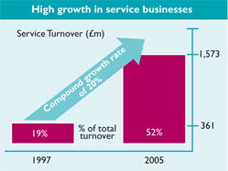
Globalisation presents many challenges to Siemens. How does Siemens in the UK remain an efficient part of the global business? How does it ensure that it continues to contribute to Siemens' overall mission, as it has done for 162 years?

One way of securing the UK business is by making sure that Siemens in the UK offers a range of top class services that add value to customers' work. A customer can buy raw materials from any supplier. The cheapest supplier, however, may not have access to technical expertise and high levels of service.

Siemens offers highly technical products with service benefits added in. This sort of service capability drives a competitive advantage over other suppliers. This is a deliberate strategy.

Questions
- Why may it not be effective for Siemens to manufacture all products in all countries?
- Describe one danger of being a multi-national company.
- How does Siemens limit this threat?

