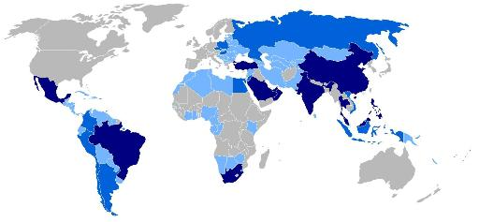
A2 Business Studies Emerging Markets

We’ve lived through an extraordinary period in world economic history. Sustained economic growth outside the areas once seen as the ‘rich world’ - primarily Western Europe, the US and Japan – is reordering the global balance of economic power.
The ‘emerging markets’ is a term used by commentators to group together some of these awakening giants. You may have heard of the BRIC economies - Brazil, Russia, India and China - a label that serves as a handy acronym to remind you of some of the key players. But there are plenty more. What does this mean for business?
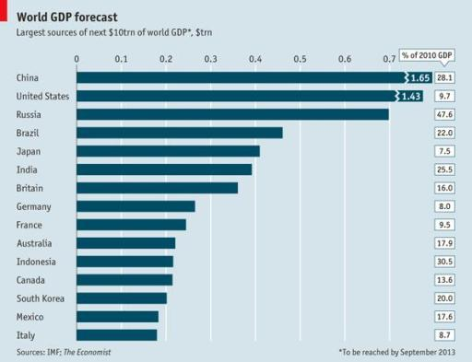
This fascinating graphic asks where will the next $10 trillion (that’s $10,000 billion, or $10,000,000 million) of world income come from. Forecasters anticipate that this might be achieved as soon as September 2013. You’ll see that much will come from some surprising sources. (If you need a guide to the idea of GDP, try here)
On one level, the rise of the emerging markets is not so amazing. It’s just the world going back to ‘normal’. What was probably odder was that there was a time when a tiny country (e.g Britain) produced 10% of all the income in the world. At the height of America’s relative power it was producing over 20% of the entire world’s income. It’s not surprising to see power shift back towards Asia, as this is where the majority of the world’s population lives.
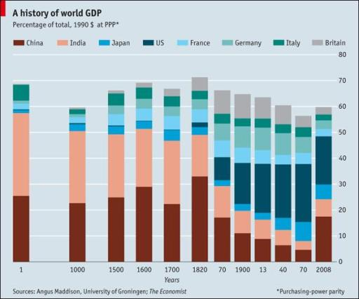
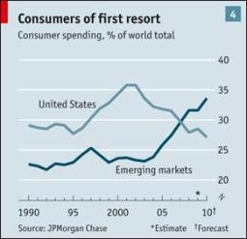
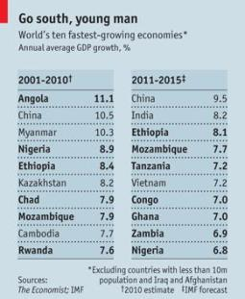
What does this mean for business?
- More and more consumption is coming from the emerging markets, with obvious implications for firms as they look abroad for export opportunities (see Prada look to cash in on Asian boom and Ford looks East in plans to become global leader - The Guardian).
- As poor countries become richer, wages and costs in those economies start to rise. That makes them less immediately attractive as places to ‘offshore’ business production (see an end to outsourcing?). Increasing growth from new sources also puts price pressure on globally traded resources like oil.
- The rising giants are producing powerful new multinational companies that increasing seek to compete in markets once dominated by the familiar rich world companies we have grown up with (something I could see first hand in China).
But you may wish to also consider that:
- At the moment, most of the population of emerging markets are still pretty poor, by our standards. It will take another couple of decades before average living standards (and shopping habits) come to resemble ours. Diversity is a tough issue for international business.
- Sadly, low levels of income and employment remain a reality for far too many people. This continues to be a significant ethical, political and business issue. Firms will still have to wade through a maze of tricky issues as they seek to move production into countries like Vietnam or Kenya. The public often views company behaviour in this area with suspicion (see the Primark Question).
- Things might change. Events in the Middle East (see the politics bit of PEST analysis) have shown how potentially unstable many of the emerging markets remain.

